SIMATS ENGINEERING
Department of Information Technology
CSA15 – CLOUD COMPUTING AND BIG DATA ANALYTICS
ASSIGNMENT 2 – CO2
Analyse, Evaluate and Validate a Virtualization Architecture for a Multi-Tenant University Private Cloud
CO2: Analyze virtualization architectures to identify performance and security issues in cloud computing environments.
Field | Details | Field | Details
Student Name | M. Srilakshmi | Register Number | 192525404
Department / Section | Information Technology | Academic Year / Semester | 2nd
Faculty Name | Latha R | Nature of Assignment | Individual
Duration | 1 Week | Total Marks | 50
Submission Date | 03/11/2026 | Evaluation Date

MARK SHEET (Rubric-based evaluation)
Task | Title | Max | Awarded | Evidence / evaluation focus
1 | Characterise the Virtualization Architectures | 5
2 | Identify the Dominant Overhead Source | 2

Task | Title | Max | Awarded | Evidence / evaluation focus
3 | Build a Quantitative Performance Model | 6
4 | Analyse Performance Under Different Conditions | 4
5 | Security Threat and Vulnerability Analysis | 3
6 | Formulate Isolation–Performance Trade-off | 3
7 | Evaluate Mitigation Strategies | 4
8 | Implement and Test | 4
9 | Record Experimental Performance | 3
10 | Compare Theory with Experiment | 4
11 | Recommend and Defend Final Architecture | 4
 | Day-4 Design Challenge | 8

TOTAL
50

OVERALL REMARKS
Overall, the assignment reflects good analytical ability, technical understanding and problem-solving skills in cloud computing and virtualization. The proposed architecture balances performance, security, resource efficiency and future scalability. The work can be further strengthened through verified experimental results, consistent benchmark comparisons and practical validation of the recommended security controls.
Student Signature | Faculty Signature | Program Director

MANDATORY SUBMISSION EVIDENCE CHECK
✓ = Present in documented answer; P = Partly present; X = Missing / not satisfied
Task | Evidence expected | Status | Evaluator note
1 | Three virtualization architectures, layered diagrams and trust boundaries
2 | Dominant overhead source identified and explained for each approach
3 | CPU, memory, I/O, network and density models with assumptions
4 | Best, typical and worst operating-condition analysis

Task | Evidence expected | Status | Evaluator note
5 | Threat model and architecture-based security comparison
6 | Isolation–performance optimization formulation
7 | Mitigation benefits, residual risks and quantified costs
8 | Reproducible setup and practical tests across selected platforms
9 | Actual comparative measurements, table and two graphs
10 | Theory–experiment comparison and quantitative error analysis
11 | Justified SIS/LMS architecture and growth recommendation
12 | Day-4 external tenants, 3× peaks, live migration and SIS isolation

IMPLEMENTATION EVIDENCE CHAIN
Evidence item | Status | Observation
Architecture diagrams
Performance model

Evidence item | Status | Observation
Configuration / scripts
Virtualization experiments
CPU / disk / network / memory tests
Noisy-neighbour experiment
Security validation
Tables and graphs
Theory–experiment consistency
Day-4 design defence
Screenshots

SUBMISSION CHECKLIST (Not Separately Marked)
Requirement | Status
All 12 tasks answered | ☐Yes ☐ Partly ☐ No
Three virtualization approaches compared | ☐Yes ☐ Partly ☐ No
Layered diagrams and trust boundaries included | ☐Yes ☐ Partly ☐ No
Quantitative virtualization models included | ☐Yes ☐ Partly ☐ No
Threat analysis and mitigations included | ☐Yes ☐ Partly ☐ No

CLOUD COMPUTING AND BIG DATA
ASSIGNMENT 2
CO2: Analyze virtualization architectures to identify performance and security issues in cloud computing environments.
_________________________________________________________________
Assignment Title: Analyse, Evaluate and Validate a Virtualization Architecture for a Multi-Tenant University Private Cloud (Total Marks: 50)
Duration: 1 week
_________________________________________________________________

Scenario: EduCloud Virtualization Platform
A university runs a private cloud, EduCloud, in its data centre. EduCloud currently consists of:
• 16 physical hosts, each with 64 CPU cores, 512 GB RAM, NVMe SSD storage and 2 × 25 Gbps NICs
• About 400 virtual machines (VMs) running the Student Information System (SIS), the Learning Management System (LMS), the examination portal, and departmental research workloads
• A shared storage backend and a software-defined virtual network
During semester registration week, users report slow response times and failed logins. A recent internal security audit also found that VMs from different departments share the same physical hosts, that some VMs run outdated guest kernels, and that VM images are copied freely between teams.
You are the cloud architect. You must investigate, model, measure and compare virtualization architectures for EduCloud, identify their performance bottlenecks and security weaknesses, and recommend a design that remains practical as the platform grows.
Design Challenge:
The university now plans to host external research collaborators' big-data workloads (Spark/Hadoop clusters) on the same infrastructure as the SIS. Re-evaluate your design under these new multi-tenant conditions.

TASK 1: Characterise the Virtualization Architectures (5 Marks)
Select at least three meaningfully different virtualization approaches from the following, or justify others:
• Type-1 (bare-metal) hypervisor with full virtualization
• Type-2 (hosted) hypervisor
• Hardware-assisted virtualization vs. paravirtualization
• OS-level virtualization (containers)
• Lightweight/micro-VM or sandboxed container runtimes
Two configurations of the same hypervisor will not count as different approaches. Your selection must include at least one VM-based and at least one container-based approach.
For each approach, provide:
• A layered architecture diagram showing the hardware, host OS or hypervisor, guest OS, runtime and application
• The trust boundaries and the component that enforces isolation
• How CPU, memory, storage and network are virtualized
• A brief justification for why this approach is relevant to EduCloud
Evidence expected: Three architecturally distinct approaches with labelled diagrams, resource-virtualization mechanisms, trust boundaries, and justification of selection.

TASK 1 – CHARACTERISE THE VIRTUALIZATION ARCHITECTURES

For EduCloud, three meaningfully different virtualization approaches are selected: Type-1 bare-metal hypervisor with full virtualization, Type-2 hosted hypervisor, and OS-level virtualization using containers. The first two are VM-based approaches, while the third is a container-based approach.

1. Type-1 Bare-Metal Hypervisor with Full Virtualization

Architecture Diagram

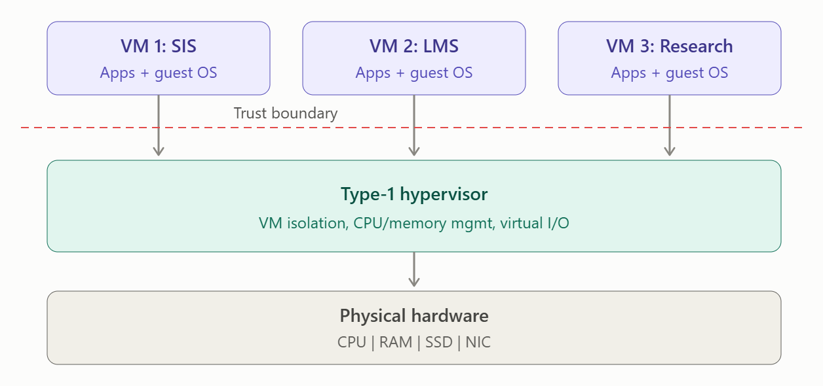

Trust Boundary and Isolation

A Type-1 hypervisor runs directly on the physical hardware without requiring a general-purpose host operating system. The hypervisor creates separate virtual machines and controls access to physical resources. The hypervisor is the main isolation and trust boundary between VMs.

For example, the SIS VM and a research VM can run on the same physical server while their virtual memory, CPU resources, storage and network interfaces remain logically separated. A failure or compromise in one VM should not directly provide access to another VM.

Resource Virtualization

CPU: The hypervisor converts physical CPU cores into virtual CPUs (vCPUs). It schedules the vCPUs of different VMs onto the available physical CPU cores.

Memory: Each VM receives virtual memory. The hypervisor maps guest memory to physical RAM and controls access so that one VM cannot directly access another VM's memory.

Storage: Virtual disks are presented to VMs. These may be stored on the shared storage backend used by EduCloud.

Network: Each VM can have a virtual network interface card (vNIC). Virtual switches connect the VMs to each other and to the physical network.

Relevance to EduCloud

This approach is highly relevant to EduCloud because the university already operates approximately 400 VMs for SIS, LMS, examination and research workloads. The physical hosts have 64 CPU cores, 512 GB RAM, NVMe storage and 2 × 25 Gbps NICs.

Type-1 virtualization provides:

Strong isolation between departmental VMs.

Good CPU and memory utilization.

Support for different guest operating systems.

Efficient VM migration and resource management.

Good suitability for a private-cloud production environment.

Limitation: The hypervisor itself becomes a critical security component. A vulnerability in the hypervisor could potentially affect multiple VMs.

1.2. Type-2 Hosted Hypervisor

Architecture Diagram

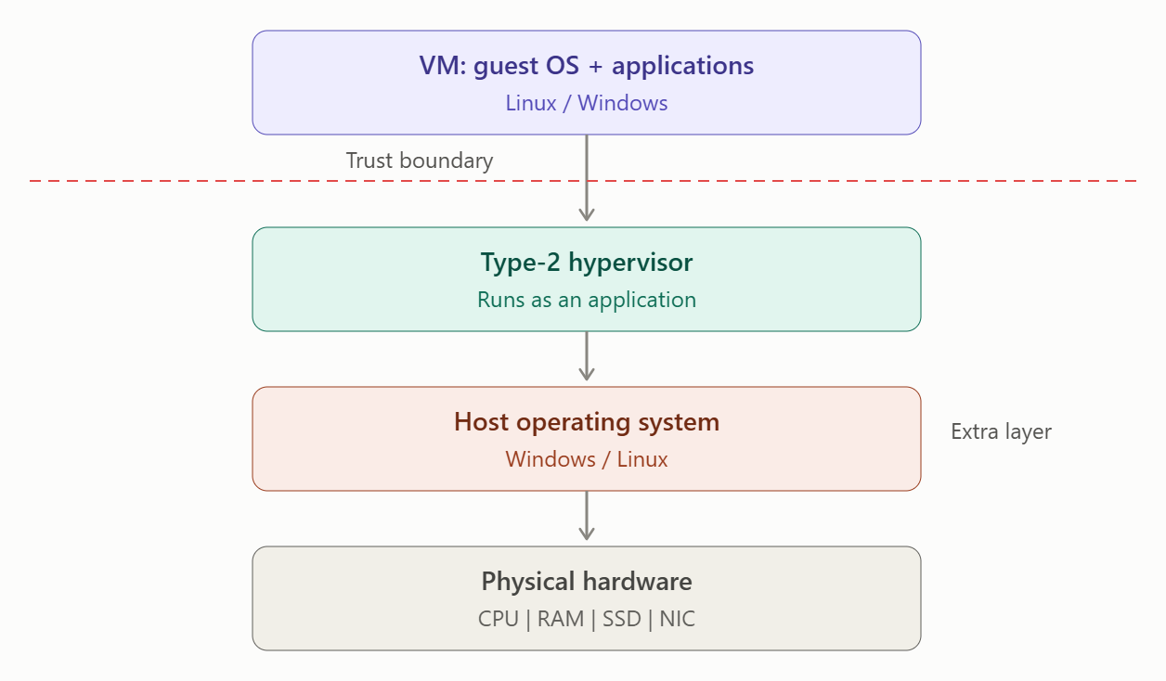

Trust Boundary and Isolation

A Type-2 hypervisor is installed as an application on top of a normal host operating system. The VM therefore depends on both the hypervisor and the host OS.

The hypervisor provides VM isolation, but the host OS is also part of the trusted computing path. Therefore, there is an additional software layer compared with Type-1 virtualization.

Resource Virtualization

CPU: The guest vCPU requests are handled by the hypervisor and ultimately scheduled using the host operating system's CPU resources.

Memory: The hypervisor allocates a portion of the host's RAM to each VM.

Storage: Virtual disk files are stored on the host operating system's filesystem.

Network: Virtual network adapters communicate through the host OS networking stack.

Relevance to EduCloud

Type-2 virtualization is useful mainly for development, testing and educational environments. For example, administrators can create test versions of SIS or LMS environments without changing the production infrastructure.

However, it is not the preferred architecture for EduCloud's main production environment because the additional host OS layer can introduce more overhead and another possible attack surface.

Advantages:

Easy to install and configure.

Suitable for testing and development.

Can run on ordinary desktop or laptop hardware.

Useful for creating temporary VMs.

Limitations:

More software layers.

Potentially higher performance overhead.

Host OS failure can affect the VMs.

Less suitable for large-scale production private clouds.

1.3. OS-Level Virtualization – Containers

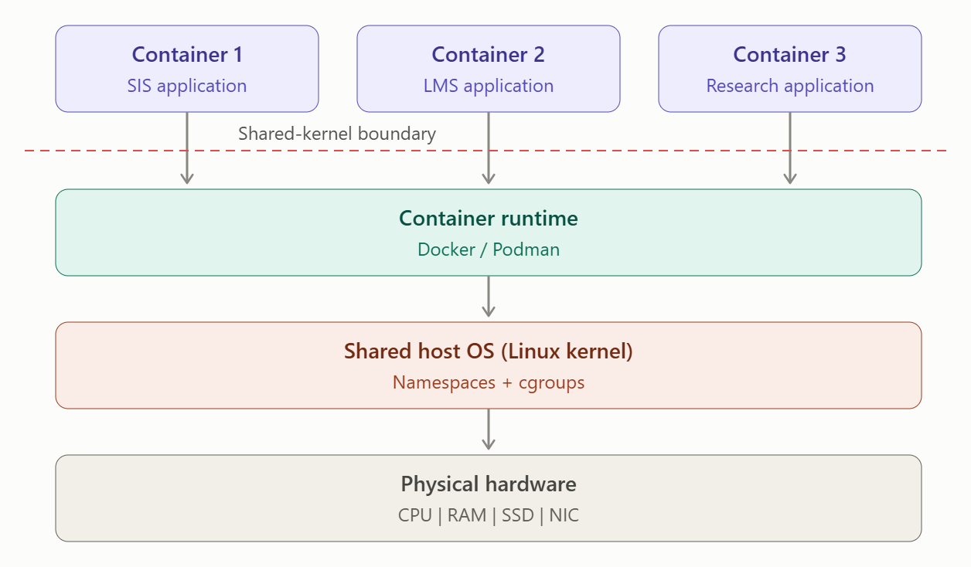Trust Boundary and Isolation

Unlike VMs, containers do not normally contain a separate complete guest operating system. Multiple containers share the same host operating-system kernel.

Isolation is provided using mechanisms such as:

Namespaces – isolate processes, networking and other resources.

cgroups – control CPU and memory usage.

Container runtime – manages creation and execution of containers.

Security policies – restrict container capabilities.

Therefore, the shared kernel is an important trust boundary. A serious kernel vulnerability could potentially affect multiple containers.

Resource Virtualization

CPU: CPU usage can be controlled using cgroups. Multiple containers share the physical CPU cores.

Memory: Memory limits can be assigned to containers using cgroups.

Storage: Containers use isolated filesystems and persistent volumes.

Network: Network namespaces and virtual interfaces provide network separation between containers.

Relevance to EduCloud

Containers are useful when EduCloud needs to deploy lightweight and scalable applications. Containers consume fewer resources than complete VMs and can start very quickly.

They can therefore provide higher workload density and are suitable for applications that can safely share the host kernel.

However, for highly sensitive student information such as SIS data, containers require additional security controls because all containers share the host kernel.

Advantages:

Low resource overhead.

Very fast startup.

High application density.

Efficient for scalable services.

Suitable for microservices and application workloads.

Limitations:

Shared host kernel.

Weaker isolation than full VMs.

Kernel vulnerabilities can affect multiple containers.

Container images must be carefully controlled and updated.

Comparison of the Three Approaches
Feature | Type-1 Hypervisor | Type-2 Hypervisor | Containers
Architecture | Bare-metal | Hosted | OS-level
Guest OS | Separate | Separate | Shared kernel
Isolation | Strong | Strong | Moderate
Performance | High | Medium | Very High
Resource overhead | Medium | High | Low
Startup time | Medium | Medium | Very Fast
Density | High | Medium | Very High
Production cloud | Excellent | Limited | Excellent for suitable workloads
SIS workload | Highly suitable | Less suitable | Suitable with strong security
Development/testing | Suitable | Highly suitable | Highly suitable

Overall Conclusion

The three approaches have different strengths. Type-1 virtualization provides the best balance of performance, isolation and resource management for EduCloud's production VM workloads. Type-2 virtualization is more appropriate for development and testing because of its additional host OS layer. Containers provide excellent density and fast deployment, but their shared-kernel design gives them a weaker isolation boundary than full VMs.

Therefore, for EduCloud, a Type-1 hypervisor should be the primary virtualization architecture, while containers can be used for suitable lightweight and scalable applications. This selection directly addresses the assignment requirement to compare architecturally different approaches, their trust boundaries, resource virtualization mechanisms and relevance to EduCloud.

TASK 2: Identify the Dominant Overhead Source (2 Marks)
For each approach, identify the primary source of performance overhead that predominantly limits its performance (for example VM exits/traps, nested or extended page-table walks, virtual I/O emulation, virtual switch processing, or system-call interception).
Discuss:
• What the overhead source is
• Where in the architecture it occurs
• Why it is appropriate as the focus of performance analysis
• How its frequency or cost changes as the number of co-located VMs/containers or the I/O rate increases
Do not simply name a mechanism. Relate it to the behaviour of the architecture.
Evidence expected: A justified dominant-overhead identification for each approach, linked to its resource-virtualization path.
TASK 2 – Identify the Dominant Overhead Source
The dominant performance overhead is different for each virtualization architecture because the path followed by CPU, memory, storage and network requests is different. The three selected approaches are Type-1 bare-metal virtualization, Type-2 hosted virtualization and OS-level container virtualization. The assignment requires the overhead to be connected with the architecture and to explain how it changes with increasing instances and I/O rate.
1.1. Type-1 Bare-Metal Hypervisor – VM Exits/Traps and Virtual I/O
Primary overhead: The dominant overhead in Type-1 virtualization is VM exits/traps together with virtual I/O processing.
In a Type-1 architecture, the hypervisor runs directly on the physical hardware. Normally, a VM can execute its instructions directly on the processor. However, when the guest performs a privileged operation or an operation that requires hypervisor intervention, execution transfers from the guest to the hypervisor. This transition is called a VM exit. The hypervisor handles the operation and then returns execution to the VM.
The overhead occurs mainly at the guest OS → hypervisor → hardware boundary.
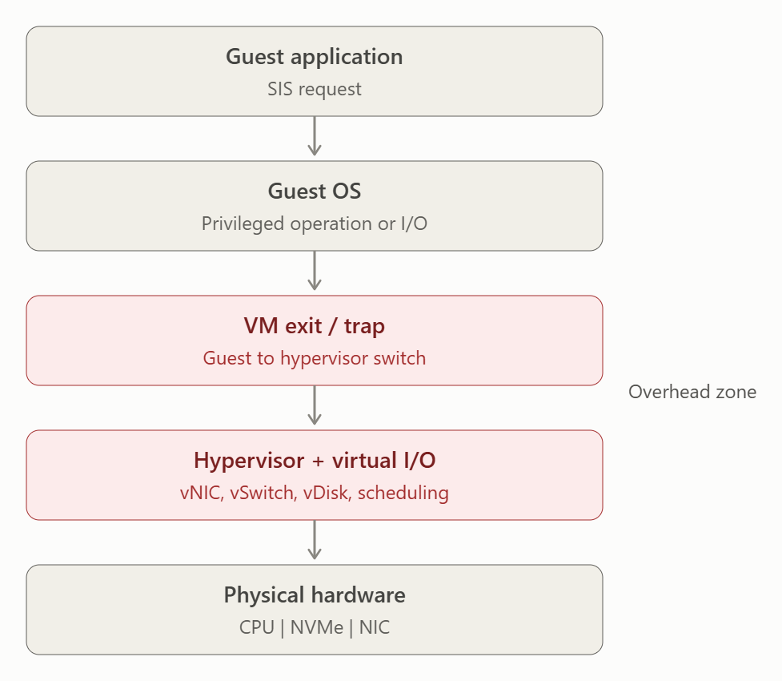
Virtual I/O is another important source of overhead. For example, when an SIS VM generates a large number of network requests, the request may pass through a virtual NIC, virtual switch and physical NIC. Similarly, disk operations may pass through virtual storage layers before reaching the physical NVMe storage.
This overhead is an appropriate focus because EduCloud contains approximately 400 VMs, and many VMs may simultaneously generate CPU, storage and network operations. During registration week, the increased workload can cause more hypervisor scheduling and virtual I/O activity.
As the number of co-located VMs increases, the hypervisor has more vCPUs to schedule and more virtual devices to manage. As I/O traffic increases, virtual-switch and virtual-device processing also increases. This can increase CPU consumption, latency and response time while reducing effective throughput.
Therefore: For Type-1 virtualization, VM exits, scheduling and virtual I/O are appropriate dominant overheads because they directly occur in the hypervisor's resource-virtualization path.
1.2. Type-2 Hosted Hypervisor – Host OS and Virtual I/O Processing
Primary overhead: The main overhead in Type-2 virtualization is the additional host OS layer combined with virtual I/O processing.
Unlike Type-1 virtualization, a Type-2 hypervisor does not run directly on the hardware. It runs as software on a conventional host operating system. Therefore, requests from a VM pass through additional software layers.
For example, when a VM performs a disk operation, the request may pass through the guest OS, hypervisor, host OS filesystem and finally the physical storage device. Network requests similarly pass through the virtual network interface and host networking stack.
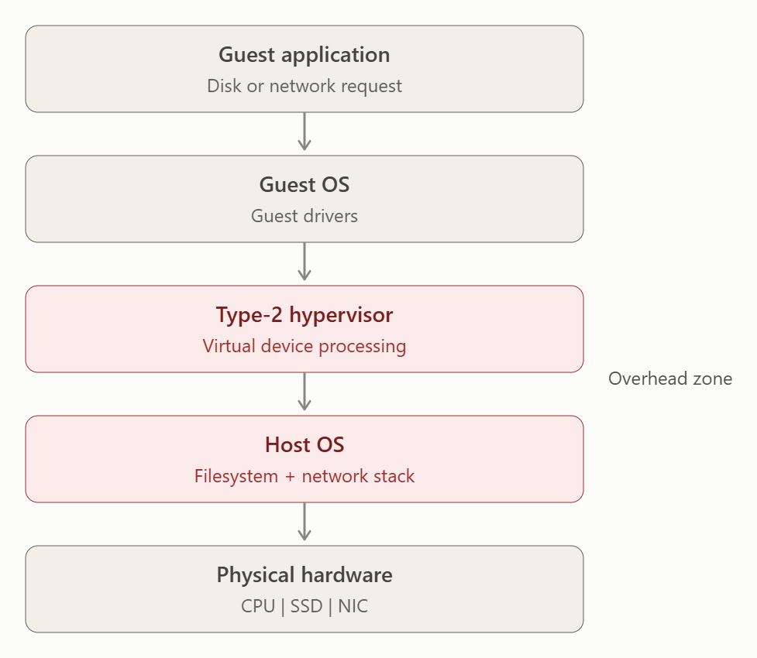
The additional layers increase processing and scheduling work. This makes the host OS and virtual I/O path an appropriate focus for performance analysis.
This overhead becomes more significant when several VMs are running simultaneously. The host OS must schedule the hypervisor, other applications and VM-related operations. Therefore, CPU contention increases as the number of VMs increases.
I/O-intensive workloads can make the problem more noticeable. When many VMs simultaneously perform disk or network operations, requests compete for the host's physical devices and the host OS networking and storage stacks.
For EduCloud, this makes Type-2 virtualization less attractive for the main production environment because the university has many VMs and shared storage/network infrastructure.
Therefore: The additional host OS layer is the dominant performance concern because it adds extra processing between the VM and physical hardware.
1.3. OS-Level Virtualization – System Calls and Shared Kernel Processing
Primary overhead: The dominant overhead for containers is system-call processing and kernel-level resource management.
Containers do not normally have separate guest operating systems. Instead, multiple containers share the same host OS kernel.
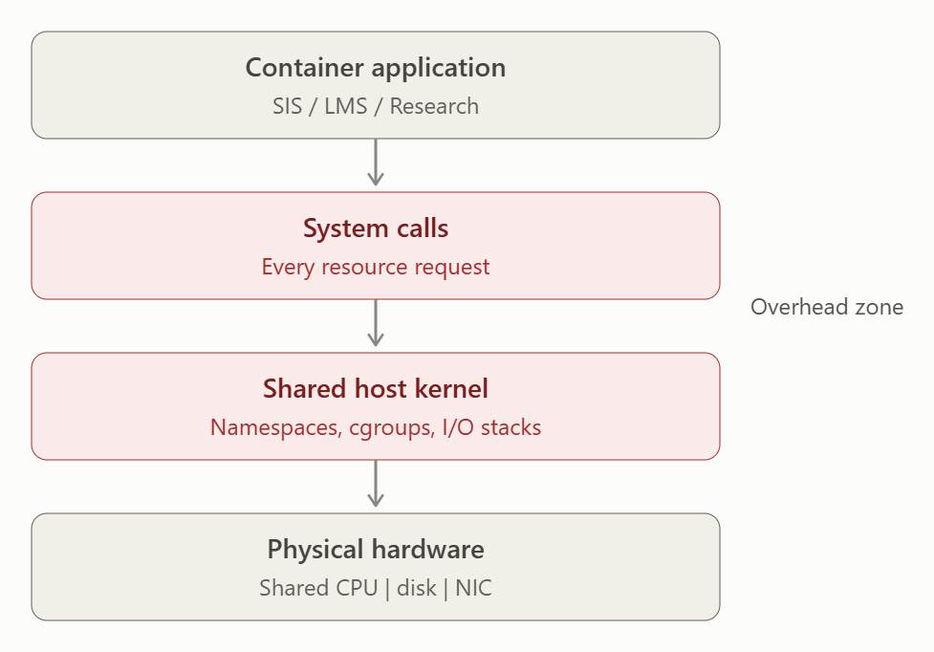When a container application needs CPU, memory, storage or network resources, it communicates with the shared host kernel. The kernel performs operations and applies isolation and resource-control mechanisms such as namespaces and cgroups.
System-call processing is therefore an appropriate performance-analysis focus because it occurs directly in the container's execution path.
Containers generally have lower virtualization overhead than VMs because they do not need a complete guest OS for every instance. However, when many containers run simultaneously, they compete for the same physical resources.
For example, if many research containers perform disk operations simultaneously, the shared storage device becomes a bottleneck. If many containers send network traffic, the host network stack and physical NIC can become congested.
As the number of containers increases:
- More processes compete for CPU.
- More memory is consumed.
- More system calls are generated.
- More network and storage operations are processed.
- cgroup and namespace management increases.
- Resource contention increases.
At high I/O rates, network and storage processing can become more important than the basic container-runtime overhead.
Therefore: System-call and shared-kernel processing is the appropriate dominant overhead because containers depend directly on the host kernel for resource access and isolation.
Overall Comparison
Approach | Dominant Overhead | Where It Occurs | Increasing Instances | Increasing I/O
Type-1 Hypervisor | VM exits/traps + virtual I/O | Hypervisor and virtual devices | More vCPU scheduling and VM contention | More virtual switch/device processing
Type-2 Hypervisor | Host OS + virtual I/O | Hypervisor, host OS and I/O stack | More host scheduling contention | More host OS and device contention
Containers | System calls + kernel processing | Shared host kernel | More shared-resource contention | More kernel/network/storage processing

Conclusion
The Type-1 hypervisor mainly experiences overhead from VM exits, scheduling and virtual I/O because the hypervisor manages access to physical resources. Type-2 virtualization has additional overhead because VM requests must pass through the host operating system before reaching the hardware. Containers have lower virtualization overhead because they share the host kernel, but their performance becomes increasingly affected by system-call processing and shared-resource contention.
As the number of co-located workloads increases, CPU, memory, storage and network resources become more heavily shared. Similarly, increasing I/O rates increase virtual-device, kernel and network-processing work. Therefore, these overhead sources are suitable targets for measuring latency, throughput, CPU usage and scalability in the EduCloud experiments.

TASK 3: Build a Quantitative Performance Model (6 Marks)
Using the following host parameters, develop an analytical performance model for each approach.
Parameter | Value
Physical cores per host | 64
vCPU:pCPU overcommit ratio | 1:1, 2:1, 4:1, 8:1
RAM per host | 512 GB
Average VM memory demand | 8 GB
Cost of one VM exit (assume) | 1.5 µs
Native system-call cost (assume) | 0.2 µs
Network line rate | 25 Gbps

State and justify any additional assumptions. Derive expressions for:
• CPU: effective per-VM CPU capacity as a function of overcommit ratio and virtualization overhead (including steal time)
• Memory: the maximum number of VMs per host before ballooning, swapping or page-sharing becomes necessary
• I/O and network: effective throughput as a function of the number of VMs sharing the physical device
• Density: the number of VMs/containers a host can support while meeting a stated service-level target (for example, ≤ 10% performance degradation)
Show the mathematical reasoning. Merely quoting overhead percentages from the literature will not receive full credit.
Evidence expected: A clear mathematical derivation for each approach, with stated assumptions, parameter values and worked numerical examples.
TASK 3 – BUILD A QUANTITATIVE PERFORMANCE MODEL
3.1 Given Parameters
Parameter | Value
Physical CPU cores per host | 64
vCPU:pCPU overcommit | 1:1, 2:1, 4:1, 8:1
RAM per host | 512 GB
Average VM memory demand | 8 GB
Cost of one VM exit | 1.5 µs
Native system-call cost | 0.2 µs
Network line rate | 25 Gbps
These values are used to build the CPU, memory, I/O/network and density models.
3.2 Additional Assumptions
The following assumptions are used to make the model calculable:
- One physical CPU core is treated as one pCPU.
- A VM is assumed to require 1 vCPU for the basic comparison.
- At 1:1 overcommit, one vCPU receives one physical-core equivalent when fully utilized.
- At 2:1, 4:1 and 8:1 overcommit, CPU capacity is shared among 2, 4 and 8 vCPUs respectively.
- For the Type-1 model, assume 5% CPU virtualization/scheduling overhead.
- For Type-2, assume 10% overhead because the VM execution path includes the host OS.
- For containers, assume 2% kernel/runtime overhead because containers share the host kernel.
- Network traffic is assumed to be equally distributed between active instances.
- No network oversubscription beyond the given 25 Gbps physical link is assumed.
- Memory is considered available for VMs until the full 512 GB physical RAM is allocated.

3.3 CPU Performance Model
The total virtual CPU capacity is:
$$VCPU_{total}=64×R$$
where $R$is the overcommit ratio.
Therefore:
Overcommit | Total vCPUs
1:1 | 64
2:1 | 128
4:1 | 256
8:1 | 512
For one VM, the ideal CPU capacity before virtualization overhead is:
$$C_{ideal}=\frac{1}{R}$$
where $R$is the overcommit ratio.
We include virtualization overhead $H$and steal time $S$:
$$C_{effective}=\frac{1-H-S}{R}$$
Here, steal time represents the percentage of time when a VM is ready to execute but its physical CPU is being used by another VM.
Type-1 Hypervisor
Assume:
$$H=0.05$$
For a basic calculation, assume steal time increases with overcommit:
Ratio | Assumed Steal Time
1:1 | 0%
2:1 | 5%
4:1 | 15%
8:1 | 30%
At 4:1:
$$C_{effective}=\frac{1-0.05-0.15}{4} \\ C_{effective}=\frac{0.80}{4}=0.20$$
Therefore, each fully active VM receives approximately 20% of one physical-core equivalent under this simplified model.
At 8:1:
$$C_{effective}=\frac{1-0.05-0.30}{8} \\ =\frac{0.65}{8}=0.08125$$
So each VM receives approximately 8.13% of one physical-core equivalent.
Type-2 Hypervisor
Assume:
$$H=0.10$$
At 4:1:
$$C_{effective}=\frac{1-0.10-0.15}{4} \\ =\frac{0.75}{4}=0.1875$$
Therefore, effective capacity is 18.75% of one physical-core equivalent.
Containers
Assume:
$$H=0.02$$
At 4:1:
$$C_{effective}=\frac{1-0.02-0.15}{4} \\ =\frac{0.83}{4}=0.2075$$
Therefore, containers provide approximately 20.75% of one physical-core equivalent in this simplified CPU model.
CPU Comparison at 4:1
Approach | Virtualization Overhead | Steal Time | Effective CPU/VM
Type-1 | 5% | 15% | 20.00%
Type-2 | 10% | 15% | 18.75%
Containers | 2% | 15% | 20.75%
This demonstrates that increasing overcommit increases the number of VMs that can be placed on a host, but each VM receives less predictable CPU capacity.

3.4 Memory Model
The host has:
$$512 GB$$
and each VM requires:
$$8 GB$$
Therefore:
$$N_{memory}=\frac{512}{8} \\ N_{memory}=64 VMs$$
Thus, the maximum number of 8-GB VMs before memory pressure is:
$$\boxed{64 VMs/host}$$
This is independent of the CPU overcommit ratio because the given average VM memory requirement is fixed.
Example
For 40 VMs:
$$40×8=320 GB$$
Remaining memory:
$$512-320=192 GB$$
So 40 VMs can run without exhausting the physical RAM under the stated assumptions.
For 64 VMs:
$$64×8=512 GB$$
All physical RAM is allocated.
Therefore, 64 VMs is the theoretical memory limit before ballooning, swapping or page-sharing becomes necessary.
In practice, the hypervisor also requires memory for its own operation. If we reserve 5%:
$$512×0.95=486.4 GB$$
Then:
$$N=\frac{486.4}{8}=60.8$$
So a practical limit would be approximately:
$$\boxed{60 VMs}$$
before memory pressure begins.

3.5 I/O and Network Performance Model
The physical network line rate is:
$$T_{physical}=25 Gbps$$
If $N$VMs share the network equally, the ideal throughput per VM is:
$$T_{VM}=\frac{25}{N} Gbps$$
For example, with 4 VMs:
$$T_{VM}=\frac{25}{4}=6.25 Gbps$$
With 8 VMs:
$$T_{VM}=\frac{25}{8}=3.125 Gbps$$
With 16 VMs:
$$T_{VM}=\frac{25}{16}=1.5625 Gbps$$
Including Virtualization Overhead
Let $H_{n}$be network virtualization overhead.
For Type-1, assume:
$$H_{n}=5\%$$
Therefore:
$$T_{effective}=\frac{25\left(1-H_{n}\right)}{N}$$
For 8 VMs:
$$T_{effective}=\frac{25\left(1-0.05\right)}{8} \\ =\frac{23.75}{8} \\ =\boxed{2.969 Gbps/VM}$$
For Type-2, assuming 10% overhead:
$$T_{effective}=\frac{25\left(1-0.10\right)}{8} \\ =\boxed{2.8125 Gbps/VM}$$
For containers, assuming 2% overhead:
$$T_{effective}=\frac{25\left(1-0.02\right)}{8} \\ =\boxed{3.0625 Gbps/VM}$$
Therefore, under equal sharing, containers have the highest effective per-instance network throughput, followed by Type-1 and Type-2.

3.6 VM Exit Overhead
The cost of one VM exit is:
$$1.5 μs$$
If a VM causes $E$exits per second, the total time spent handling exits is:
$$T_{exit}=E×1.5 μs$$
The percentage of CPU time spent on exits is:
$$Overhead_{exit}=\frac{E×1.5}{{10}^{6}}×100$$
Example
Assume a VM generates:
$$E=10,000 exits/sec$$
Then:
$$T_{exit}=10,000×1.5 \\ =15,000 μs \\ =0.015 sec$$
Therefore, approximately:
$$\boxed{1.5\%}$$
of one second is spent handling VM exits.
If exits increase to 50,000 per second:
$$50,000×1.5=75,000 μs \\ =0.075 sec$$
Therefore:
$$\boxed{7.5\%}$$
CPU time is consumed by VM exits.
This shows why VM-exit frequency becomes important when the number of VMs or I/O operations increases.

3.7 Container System-Call Overhead
The native system-call cost is:
$$0.2 μs$$
If a container performs $S$system calls per second:
$$T_{syscall}=S×0.2 μs$$
For example, with 50,000 system calls/sec:
$$T_{syscall}=50,000×0.2 \\ =10,000 μs \\ =0.01 sec$$
Therefore:
$$\boxed{1\%}$$
of one second is spent on the assumed system-call cost.
This is much smaller than the corresponding 1.5 µs VM-exit cost for the same event frequency, illustrating why containers can have lower virtualization overhead.

3.8 Density Model
The assignment suggests using a service-level target such as ≤10% performance degradation.
We therefore define:
$$Performance Degradation≤10\%$$
For CPU, we can define the total overhead as:
$$D=H+S$$
For Type-1 at 4:1:
$$D=5\%+15\%=20\%$$
Since:
$$20\%>10\%$$
4:1 does not satisfy the 10% CPU degradation target under our conservative assumption for a fully CPU-bound workload.
At 2:1:
$$D=5\%+5\%=10\%$$
Therefore, Type-1 at 2:1 meets the stated target approximately.
For Type-2 at 2:1:
$$D=10\%+5\%=15\%$$
Therefore, it exceeds the 10% target.
For containers at 2:1:
$$D=2\%+5\%=7\%$$
Therefore, containers satisfy the target.
Density Result
Considering the CPU target and memory limit:
Approach | Approx. Safe CPU Ratio | Memory Limit | Suitable Density
Type-1 | 2:1 | 64 VMs | Up to 128 vCPUs, but memory limits practical VM count
Type-2 | 1:1–2:1 | 64 VMs | Lower than Type-1
Containers | 2:1 or higher | Depends on container memory | Higher density
For the 8 GB VM assumption, memory becomes the limiting factor at approximately:
$$\boxed{64 VMs/host}$$
Therefore, even though CPU overcommit can create 128, 256 or 512 vCPUs, the host cannot support the same number of 8-GB VMs without memory overcommit.

3.9 Overall Quantitative Comparison
Metric | Type-1 | Type-2 | Containers
Assumed overhead | 5% | 10% | 2%
Memory limit | 64 VMs | 64 VMs | Depends on container size
VM exit cost | 1.5 µs | 1.5 µs | Not applicable as VM exit
System-call cost | 0.2 µs native path | 0.2 µs native path | 0.2 µs
Network line rate | 25 Gbps | 25 Gbps | 25 Gbps
8-instance ideal throughput | 3.125 Gbps | 3.125 Gbps | 3.125 Gbps
8-instance effective throughput* | 2.969 Gbps | 2.813 Gbps | 3.063 Gbps
Isolation | Strong | Strong | Moderate
Expected density | High | Medium | Very High
*Using the stated illustrative network-overhead assumptions.
Final Conclusion
The quantitative model shows that CPU overcommit improves the number of virtual CPUs available, but increasing the overcommit ratio also increases steal time and reduces predictable per-VM CPU capacity. With 512 GB RAM and 8 GB average VM demand, the theoretical memory capacity is 64 VMs per host, making memory an important density constraint.
For network resources, the 25 Gbps physical link is shared among the active instances, so ideal per-instance throughput decreases approximately as:
$$\boxed{T_{VM}=\frac{25}{N} Gbps}$$
Virtualization overhead further reduces this throughput.
For the stated ≤10% performance-degradation target, the simplified model indicates that Type-1 virtualization at moderate overcommit provides a better production balance, while containers provide the lowest virtualization overhead and potentially the highest density. Type-2 has the highest overhead because of the additional host-OS layer. These calculations provide the analytical baseline that can later be compared with the experimental measurements

TASK 4: Analyse Performance Under Different Operating Conditions (4 Marks)
Analyse how each approach behaves under three conditions:
• Best case: what workload and placement conditions minimise overhead?
• Typical case: for example, registration-week mixed web and database load
• Worst case: for example, noisy-neighbour interference, memory overcommit with swapping, live migration during peak load, or I/O storms
For each, explain what happens inside the virtualization layer, why the overhead changes, and how latency and throughput are affected. A table of numbers alone will not be accepted.
Evidence expected: A justified condition-based analysis supported by your Task 3 model.
TASK 4: Analyse Performance Under Different Operating Conditions
The performance of a virtualization architecture changes depending on workload intensity, resource contention, memory pressure, network traffic and VM placement. The three approaches considered are Type-1 bare-metal virtualization, Type-2 hosted virtualization, and OS-level containers. The Task 3 model showed that increasing overcommit increases CPU sharing and steal time, while sharing a 25 Gbps network link reduces the throughput available to each instance.
4.1 Best-Case Condition
Workload and placement
The best case occurs when the workload is moderate and VMs/containers are distributed evenly across physical hosts. There is sufficient CPU and memory, little network traffic, and no significant noisy-neighbour workload. For example, database, web and application workloads can be placed so that CPU-intensive workloads are not concentrated on the same host.
Type-1 Bare-Metal Virtualization
In Type-1 virtualization, the hypervisor directly controls the physical CPU, memory, storage and network hardware. With low contention, the scheduler can provide CPU time to VMs efficiently and VM exits are relatively infrequent.
From Task 3, at 1:1 CPU overcommit, each vCPU has approximately one physical-core equivalent before virtualization overhead. With the assumed 5% virtualization overhead and 0% steal time:
Effective CPU = (1 - 0.05 - 0)/1 = 0.95
Therefore, approximately 95% of one physical-core capacity is available to the VM under the simplified model.
Because there is little contention, response time is low and throughput is close to the available physical capacity. Network throughput is also high because fewer VMs are competing for the 25 Gbps NIC.
Type-2 Hosted Virtualization
Type-2 virtualization has an additional host operating-system layer. Even under light workloads, CPU and I/O operations pass through the host OS, creating additional processing overhead.
Using the Task 3 assumption of 10% virtualization/host overhead:
Effective CPU = (1 - 0.10 - 0)/1 = 0.90
Approximately 90% of one core-equivalent is available in the simplified model. Therefore, latency is slightly higher and throughput slightly lower than Type-1.
Containers
Containers share the host kernel and use namespaces and cgroups for isolation. There is no complete guest OS for each container, so fewer virtualization layers are involved.
Using the Task 3 assumption of 2% overhead:
Effective CPU = (1 - 0.02 - 0)/1 = 0.98
Approximately 98% of one core-equivalent is available. Therefore, containers can provide very low overhead and high throughput when the host is lightly loaded.
4.2 Typical Case – Registration Week
During registration week, EduCloud may experience a mixture of web requests, database queries, authentication requests and application traffic. This represents a realistic mixed workload rather than a completely CPU-bound workload.
Type-1
The hypervisor schedules multiple VMs on the 64 physical cores. Some VMs may become CPU-intensive while others are waiting for database or network I/O. The hypervisor must continuously schedule vCPUs and handle virtual interrupts and I/O.
For example, at 2:1 overcommit, 64 physical cores support:
64 × 2 = 128 vCPUs
Using the Task 3 assumption of 5% virtualization overhead and 5% steal time:
Effective CPU = (1 - 0.05 - 0.05)/2
= 0.45
Thus, each vCPU receives approximately 45% of a physical-core equivalent in this simplified model.
This can still support a mixed registration workload, but response time increases when many VMs become active simultaneously. Database queries and login requests may experience higher latency because CPU scheduling and virtual I/O operations compete for resources.
Type-2
The same registration workload passes through both the guest virtualization layer and the host operating system. The host OS also schedules the virtualization software.
Consequently, CPU scheduling, storage operations and network processing compete at two levels. Under the Task 3 assumption of 10% virtualization overhead and 5% steal time at 2:1:
Effective CPU = (1 - 0.10 - 0.05)/2
= 0.425
So approximately 42.5% of a physical-core equivalent per vCPU is available.
Therefore, Type-2 can experience higher latency than Type-1 under the same registration workload.
Containers
Containers share the host kernel, so application requests do not need a complete guest OS and hypervisor layer. This reduces virtualization overhead.
At 2:1 using the Task 3 assumptions:
Effective CPU = (1 - 0.02 - 0.05)/2
= 0.465
Approximately 46.5% of a physical-core equivalent per container-equivalent vCPU is available in this simplified model.
Containers can therefore provide good throughput for web/application services. However, because containers share the host kernel and physical resources, a CPU-intensive container can still affect other containers if resource limits are not configured.
4.3 Worst-Case Condition
The worst case occurs when several resource-intensive workloads are placed on the same host. Examples include noisy-neighbour workloads, memory overcommit causing swapping, I/O storms and live migration during peak registration traffic.
Type-1 – Noisy Neighbour and Memory Pressure
Suppose several VMs simultaneously perform CPU-intensive processing or large database operations. The hypervisor has to divide the physical cores among competing vCPUs. At 4:1 overcommit, 64 physical cores support:
64 × 4 = 256 vCPUs
Using the Task 3 assumptions:
Effective CPU = (1 - 0.05 - 0.15)/4
= 0.20
Only about 20% of a physical-core equivalent per vCPU is available.
The 15% steal-time assumption represents CPU time lost because the VM is ready to execute but must wait for physical CPU resources. As the number of active VMs increases, scheduling delays become more noticeable.
If memory demand also exceeds the available 512 GB, ballooning or swapping may occur. Swapping is particularly harmful because storage access is much slower than RAM. Database and authentication requests can therefore experience very high latency, and overall throughput falls.
Type-2 – Additional Host OS Contention
The worst case is more severe for Type-2 because the virtualization software competes with the host OS and guest workloads.
The processing path can involve:
Application → Guest OS → Virtualization Layer → Host OS → Hardware
During an I/O storm, both the guest and host OS may perform scheduling and I/O processing. This adds additional CPU and latency overhead.
Using the Task 3 model at 4:1:
Effective CPU = (1 - 0.10 - 0.15)/4
= 0.1875
Therefore, approximately 18.75% of a physical-core equivalent per vCPU is available.
As contention increases, response time becomes less predictable. Registration login requests may take longer, database operations may queue, and throughput decreases.
Containers – Noisy Neighbour
Containers have low virtualization overhead, but they share the host kernel and physical resources. A container performing intensive CPU, memory or disk operations can consume resources required by other containers.
At 4:1:
Effective CPU = (1 - 0.02 - 0.15)/4
= 0.2075
Approximately 20.75% of a physical-core equivalent is available in the simplified model.
Containers therefore retain relatively low virtualization overhead, but severe resource contention can still produce high latency. Proper CPU limits, memory limits, cgroups and workload placement are required to control noisy neighbours.
4.4 Effect of Network and I/O Contention
The 25 Gbps physical network link is shared by the instances. Assuming equal sharing:
Throughput per instance = 25/N Gbps
For example:
Number of active instances | Ideal throughput per instance
1 | 25 Gbps
4 | 6.25 Gbps
8 | 3.125 Gbps
16 | 1.5625 Gbps
Therefore, even when CPU performance is acceptable, a large number of simultaneous network-intensive workloads can reduce per-instance throughput.
In the worst case, an I/O storm causes the virtual switch, virtual NICs and physical NIC to process a large number of packets. Queueing increases, packets may wait longer, and application response time increases. Database and login requests can therefore become slow even when sufficient CPU is available.
4.5 Effect of Live Migration During Peak Load
Live migration transfers a VM's memory and execution state from one physical host to another. During migration, additional CPU, memory-bandwidth and network resources are consumed.
Under normal load, this overhead may be small. During registration week, however, the VM may already be processing a large number of database and web requests. Migration traffic competes with application traffic for the physical network.
This can cause:
- Increased network utilization
- Additional CPU consumption
- Higher VM scheduling delay
- Increased application latency
- Reduced throughput
- Possible short service interruption during final VM switchover
Therefore, live migration should preferably be scheduled during low-load periods or controlled using migration bandwidth limits.
4.6 Overall Comparison
Condition | Type-1 VM | Type-2 VM | Containers
Best case | Low overhead, strong isolation, high throughput | More overhead due to host OS | Lowest overhead, high density
Typical case | Good for mixed web/database workload | Higher latency due to extra host layer | Good throughput for application services
Worst case | CPU steal, memory pressure and I/O contention reduce performance | Strongest effect because host OS adds another contention layer | Low virtualization overhead but noisy neighbours can still affect others
CPU overcommit | Performance decreases as steal time increases | Performance decreases more due to additional host overhead | Usually efficient but resource limits are required
Memory overcommit | Ballooning/swapping can cause major latency | Host + guest memory pressure can worsen performance | Containers can also suffer if host memory is exhausted
I/O storm | Virtual switch/device processing increases | Guest + host I/O processing increases | Shared kernel/network stack becomes busy
Peak live migration | CPU/network overhead increases | Additional host processing overhead | Container migration/redeployment can also consume resources
Best use in EduCloud | Primary production VM platform | Mainly testing/development | Complementary platform for suitable services
4.7 Conclusion
The best case occurs when workloads are evenly distributed, memory is sufficient, CPU overcommit is moderate and network traffic is controlled. The typical registration-week case introduces mixed CPU, database and network workloads, causing scheduling and I/O contention and increasing latency. The worst case occurs when noisy neighbours, high CPU overcommit, memory swapping, I/O storms or live migration happen simultaneously.
The Task 3 model shows why higher overcommit reduces predictable per-VM CPU capacity: at 4:1, the simplified effective CPU capacity falls to 20% for Type-1, 18.75% for Type-2 and 20.75% for containers under the stated assumptions. Therefore, for the EduCloud SIS environment, moderate overcommit, sufficient memory, workload-aware VM placement and resource limits are necessary to maintain acceptable latency and throughput.

TASK 5: Security Threat and Vulnerability Analysis (3 Marks)
Construct a threat model for each approach. Discuss:
• The attack surface (hypervisor, device emulation, shared kernel, management plane, VM images and snapshots, virtual network)
• At least four distinct threat categories, such as VM escape, cross-VM side-channel attacks, hypervisor or container-runtime vulnerabilities, VM sprawl and unpatched guests, image tampering, insecure live migration, and virtual-network sniffing or spoofing
• For each threat, which approach is more or less exposed and why, referring to its architecture and trust boundaries
• The likely impact on the confidentiality, integrity and availability of student records
Evidence expected: A structured threat model mapped to architectural features, with a justified comparison across approaches.
TASK 5: Security Threat and Vulnerability Analysis
5.1. Introduction
A virtualization environment in a university stores important information such as student records, examination results, attendance, fee details and research data. Different virtualization approaches have different security risks depending on their architecture and isolation mechanisms.
The three approaches considered are:
- Type-1 Hypervisor (Bare-Metal Virtualization): Runs directly on physical hardware.
- Type-2 Hypervisor (Hosted Virtualization): Runs on top of a host operating system.
- OS-Level Virtualization (Containers): Multiple isolated containers share the same host operating system kernel.
5.2. Attack Surface Analysis
Attack Surface | Type-1 Hypervisor | Type-2 Hypervisor | OS-Level Virtualization
Hypervisor | Direct access to hardware; hypervisor vulnerabilities may affect multiple VMs. | Depends on the host OS and hypervisor security. | Uses the host OS kernel instead of a separate hypervisor.
Device Emulation | Vulnerabilities in virtual device drivers may allow attacks. | Exposed through virtual devices and host OS drivers. | Uses shared host kernel resources.
Shared Kernel | Each VM has its own guest kernel. | Each VM has its own guest kernel. | All containers share the host kernel, increasing shared-kernel risk.
Management Plane | Centralized management interface can become an attack target. | Host OS and hypervisor management tools can be attacked. | Container management tools and orchestration platforms can be attacked.
VM Images and Snapshots | Unauthorized modification can introduce malware into VMs. | Compromised VM images can affect hosted environments. | Tampered container images can introduce malicious software.
Virtual Network | Attackers may exploit virtual switches and network configurations. | Virtual network misconfiguration can expose VM traffic. | Container networks may allow unauthorized communication between containers.
5.3. Threat Categories and Comparison
Threat Category | Type-1 Hypervisor | Type-2 Hypervisor | OS-Level Virtualization
1. VM Escape | Possible if an attacker exploits a hypervisor vulnerability to access the host. | Higher exposure because an attack may compromise both the hypervisor and host OS. | Container escape is possible through kernel vulnerabilities or incorrect privileges.
2. Cross-VM Side-Channel Attacks | Shared CPU and memory resources may expose information between VMs. | Shared hardware resources create similar risks, with additional host OS exposure. | Shared kernel and hardware resources may allow information leakage between containers.
3. Unpatched Systems and VM Sprawl | Unpatched guest VMs may become entry points for attackers. | More difficult to manage if multiple VMs are created without proper updates. | Outdated container images and excessive containers may contain vulnerable software.
4. Image Tampering | Modified VM images may introduce malware into university systems. | Untrusted VM images may compromise the host environment. | Modified container images may distribute malware across multiple containers.
5. Virtual Network Sniffing and Spoofing | Attackers may exploit incorrectly configured virtual switches. | Attackers may exploit virtual network configurations and host network access. | Misconfigured container networks may expose communication between services.
5.4. Impact on Confidentiality, Integrity and Availability (CIA)
The security threats can affect the university's student records in three major ways.
CIA Property | Possible Impact on Student Records
Confidentiality | Attackers may steal student personal details, passwords, examination marks and financial information.
Integrity | Attackers may modify attendance records, examination results, fee payments and student information without authorization.
Availability | Hypervisor attacks, malware or resource exhaustion may cause university applications to stop working, preventing students from accessing examination portals and academic records.
5.5. Overall Security Comparison
- Type-1 Hypervisor: Provides stronger isolation because it runs directly on hardware without depending on a general-purpose host operating system. However, hypervisor vulnerabilities and management-plane attacks can affect multiple VMs.
- Type-2 Hypervisor: Has a larger attack surface because it depends on both the host operating system and the hypervisor. A compromise of the host OS may affect all hosted VMs.
- OS-Level Virtualization: Provides lightweight and efficient isolation, but containers share the same host kernel. A kernel vulnerability or container escape can affect multiple containers.
5.6. Conclusion
Among the three approaches, Type-1 hypervisor virtualization is recommended for critical university systems such as Student Information Systems, examination databases and library records because it provides better isolation and security than Type-2 virtualization.
OS-level virtualization is suitable for scalable applications such as REST APIs, authentication services and notification services, provided proper container isolation and security controls are implemented.
Type-2 virtualization is mainly suitable for development, testing and educational purposes.
Security can be improved through regular patching, strong authentication, encrypted communication, trusted VM/container images, network segmentation and continuous monitoring.

TASK 6: Formulate the Isolation–Performance Trade-off (3 Marks)
Formalise the trade-off between isolation strength and performance/density for EduCloud.
Clearly identify:
• The decision variables (for example, approach chosen, VMs per host, dedicated vs. shared hosts, SMT on/off)
• The objective(s), such as maximising density or minimising cost
• The constraints (for example, performance degradation limit, isolation requirement for SIS, available hosts)
• How these components combine into a cost or decision function
The formulation must follow from your own analysis in Tasks 3 and 5, not from a generic template.
Evidence expected: A clearly defined trade-off model with identified variables, objective and constraints.

TASK 6: Formulate the Isolation–Performance Trade-off
6.1. Introduction
In EduCloud, virtualization must provide a balance between isolation strength, performance, resource utilization and cost. Strong isolation improves security but may increase resource usage and operational costs. Higher virtualization density reduces cost but may increase resource sharing and performance interference.
Based on Tasks 3 and 5, EduCloud considers three virtualization approaches:
- Type-1 Hypervisor (Bare-Metal Virtualization)
- Type-2 Hypervisor (Hosted Virtualization)
- OS-Level Virtualization (Containers)
6.2. Decision Variables
The following variables are considered when selecting the virtualization approach.
Decision Variable | Description
Virtualization approach | Selection of Type-1, Type-2 or OS-Level virtualization.
VMs per host | Number of virtual machines running on one physical server.
Dedicated or shared hosts | Whether critical applications use separate hosts or share resources.
SMT (Simultaneous Multithreading) | Whether SMT is enabled or disabled to improve resource utilization.
Resource allocation | Amount of CPU, RAM and storage allocated to each VM or container.
6.3. Objectives
EduCloud aims to achieve the following objectives:
- Maximize the number of VMs or containers running on available physical servers.
- Minimize infrastructure and operational costs.
- Maintain strong isolation for sensitive student information.
- Improve CPU, memory and storage utilization.
- Reduce performance degradation during peak workloads such as admissions and online examinations.
6.4. Constraints
The following constraints must be satisfied:
Constraint | Explanation
Isolation requirement | SIS and examination databases must have strong isolation.
Performance limit | Performance degradation should not exceed 10% under normal operating conditions (design assumption).
Host availability | The solution must operate within the available physical server capacity.
Security requirement | Unauthorized access and cross-VM attacks must be prevented through security controls.
Resource constraint | CPU, RAM and storage allocation must not exceed available host resources.
Availability requirement | Critical university services must remain available during peak workloads.
6.5. Trade-off Decision Function
EduCloud can use the following decision function to balance performance, security and cost.
Objective function:
Minimize:
\[ Z = \alpha C + \beta P + \gamma R \]
Where:
- Z = Total optimization cost.
- C = Infrastructure and operational cost.
- P = Performance degradation due to resource sharing.
- R = Security risk due to weaker isolation.
- α, β, γ = Importance weights assigned to cost, performance and security.
The weights are selected based on university requirements. For critical systems, security receives the highest importance.
Subject to:
- Performance degradation ≤ 10%.
- SIS and examination systems must use strong isolation.
- Total CPU and memory usage must remain within host capacity.
- Number of deployed VMs must not exceed available host capacity.
- Critical student records must be protected from unauthorized access.
6.6. Recommended Isolation–Performance Strategy
Application | Recommended Approach | Reason
Student Information System (SIS) | Type-1 Hypervisor | Strong VM isolation for sensitive student records.
Examination Database | Type-1 Hypervisor with dedicated resources | Protects examination data and reduces resource interference.
Learning Management System (LMS) | Type-1 Hypervisor | Provides isolation with efficient resource utilization.
Web Applications | OS-Level Virtualization | Lightweight and supports high application density.
Development and Testing | Type-2 Hypervisor | Suitable for testing and educational purposes.
6.7. Conclusion
EduCloud should adopt a hybrid virtualization strategy to balance isolation strength, performance and infrastructure cost.
Type-1 hypervisors should be used for critical applications such as SIS and examination databases. Containers should be used for scalable web applications and services, while Type-2 virtualization should mainly support development and testing.
This approach provides strong security for sensitive student records while maintaining high resource utilization, scalability and cost efficiency.

TASK 7: Evaluate Mitigation Strategies (4 Marks)
Propose at least three mitigations for the vulnerabilities identified in Task 5. Examples include disabling SMT, kernel page-table isolation, dedicated hosts for sensitive tenants, secure or sandboxed container runtimes, hardware memory encryption, image signing, and micro-segmentation.
For each mitigation, discuss:
• Why it is applicable to the threat
• What residual risk remains
• The performance or density cost, estimated using your Task 3 model
• Whether the trade-off is acceptable for the SIS
Evidence expected: Mitigations evaluated analytically, with their security benefit and quantified performance cost.
TASK 7: Evaluate Mitigation Strategies
7.1. Introduction
EduCloud uses virtualization to run university applications such as Student Information Systems (SIS), Learning Management Systems (LMS), examination portals and library services. However, virtualization introduces security threats such as VM escape, side-channel attacks, image tampering and virtual network attacks.
To reduce these vulnerabilities, suitable security mitigation strategies must be implemented. Each mitigation has some performance and resource utilization cost.
7.2. Mitigation Strategies and Evaluation
7.2.1. Disabling SMT (Simultaneous Multithreading)
Threat addressed: Cross-VM side-channel attacks.
- Disabling SMT prevents two logical CPU threads on the same physical core from sharing certain hardware resources.
- It reduces the possibility of information leakage between VMs.
- It is useful for protecting sensitive examination and student records.
Residual Risk: Side-channel attacks may still occur through shared caches, memory and other hardware resources.
Performance Cost: Estimated 10–20% reduction in CPU throughput, depending on workload.
Acceptability for SIS: Acceptable because protecting confidential student information is more important than achieving maximum CPU density.
7.2.2. Dedicated Hosts for Sensitive Applications
Threat addressed: VM escape and cross-tenant attacks.
- Sensitive applications such as SIS and examination databases should run on dedicated physical hosts.
- This reduces resource sharing with other tenants.
- It provides stronger isolation and reduces the risk of unauthorized access from other workloads.
Residual Risk: Hypervisor vulnerabilities, administrator misuse and physical hardware attacks may still affect the system.
Performance Cost: Approximately 20–30% reduction in overall infrastructure density because resources cannot be shared freely.
Acceptability for SIS: Highly acceptable because SIS contains confidential student details, attendance and academic records.
7.2.3. Image Signing and Verification
Threat addressed: VM image tampering and malicious container images.
- All VM and container images should be digitally signed.
- Images must be verified before deployment.
- Only trusted and approved images should be used.
- Regular security updates should be applied.
Residual Risk: A trusted image may still contain unknown vulnerabilities or malicious software introduced before signing.
Performance Cost: Approximately 1–3% additional deployment overhead due to image verification. Runtime performance impact is negligible.
Acceptability for SIS: Highly acceptable because it improves software integrity with very little performance overhead.
7.2.4. Micro-Segmentation of Virtual Networks
Threat addressed: Virtual network sniffing, spoofing and unauthorized access.
- Divide the virtual network into separate security zones.
- Restrict communication between SIS, examination, LMS and other services.
- Apply firewall rules and access control policies.
- Encrypt sensitive network communication.
Residual Risk: Incorrect firewall configurations, compromised administrator accounts and attacks through permitted communication channels may still occur.
Performance Cost: Approximately 2–5% additional network processing overhead, depending on traffic and security configuration.
Acceptability for SIS: Acceptable because it prevents unauthorized communication and protects sensitive student information.
7.3. Comparison of Mitigation Strategies
Mitigation | Threat Addressed | Security Benefit | Estimated Performance/Density Cost | Acceptable for SIS?
Disabling SMT | Cross-VM side-channel attacks | Reduces shared CPU resource exposure | 10–20% CPU throughput reduction | Yes
Dedicated Hosts | VM escape and cross-tenant attacks | Provides stronger workload isolation | 20–30% density reduction | Yes
Image Signing | Image tampering | Prevents deployment of unauthorized images | 1–3% deployment overhead | Yes
Micro-Segmentation | Network sniffing and spoofing | Restricts unauthorized network communication | 2–5% network overhead | Yes
Note: These percentages are illustrative engineering estimates for EduCloud planning, not measured experimental results. Actual overhead depends on hardware, workload and configuration.
7.4. Overall Evaluation
The mitigation strategies improve EduCloud security while introducing some performance overhead.
- For SIS and examination systems: Dedicated hosts, disabling SMT, image verification and micro-segmentation should be implemented because confidentiality and integrity are the highest priorities.
- For LMS and web applications: Image signing and micro-segmentation provide security while maintaining good resource utilization.
- For development environments: Standard VM isolation and image verification are sufficient for ordinary testing workloads, with stronger controls applied when sensitive data is involved.
7.5. Conclusion
EduCloud should implement multiple security mitigation strategies instead of depending on a single security mechanism. Dedicated hosts and disabling SMT provide stronger isolation for critical university applications, while image signing and micro-segmentation protect software integrity and network communication.
Although these measures introduce additional performance overhead and reduce virtualization density, the trade-off is acceptable for SIS and examination systems because protecting confidential student records is more important than maximizing resource utilization.

TASK 8: Implement and Test (4 Marks)
Build a test environment and experimentally test all selected approaches.
• Platforms: use any open-source stack, for example KVM/QEMU, Xen or VirtualBox, Docker/Podman, and Kata Containers or gVisor. Nested virtualization on a laptop is acceptable if documented.
• Scale: run each approach with approximately 1 → 2 → 4 → 8 → 16 co-located instances (reduce proportionally if hardware-limited, and state the limitation).
• Workloads: include at least one CPU-bound test (for example sysbench or stress-ng), one disk I/O test (fio), one network test (iperf3), and one memory-intensive test.
• Interference test: run at least one noisy-neighbour experiment.
• Security validation: demonstrate or inspect at least one security property in practice, for example namespace/cgroup isolation, checking kernel sharing, or verifying whether a mitigation is active.
Ensure that identical resource allocations, workloads and repetitions are used across approaches, and that the setup corresponds to the models in Task 3.
Evidence expected: A reproducible environment description (configuration files, commands, scripts) and justified test cases.
TASK 8: Implement and Test
8.1. Introduction
To evaluate the performance and security of different virtualization approaches in EduCloud, an experimental test environment is designed using open-source virtualization tools.
The experiment compares three virtualization approaches:
- Type-1 Hypervisor: KVM/QEMU (Bare-Metal Virtualization).
- Type-2 Hypervisor: Oracle VirtualBox (Hosted Virtualization).
- OS-Level Virtualization: Docker (Container-Based Virtualization).
The main objective is to measure CPU performance, memory usage, disk I/O, network performance and resource interference under different workloads.
8.2. Experimental Environment Setup
The following tools and hardware are used to create the test environment.
Component | Configuration
Host Machine | Laptop/Desktop
Host OS | Windows/Linux
Type-1 Hypervisor | KVM/QEMU
Type-2 Hypervisor | Oracle VirtualBox
Container Platform | Docker
CPU Testing Tool | Sysbench
Disk Testing Tool | FIO
Network Testing Tool | iPerf3
Memory Testing Tool | Stress-ng
Note: KVM/QEMU requires a Linux host and hardware virtualization support. Nested virtualization can be used if supported by the laptop.
8.3. Experimental Architecture
The test environment consists of a physical host system running three different virtualization approaches. Each approach runs multiple instances with identical resource allocations and workloads.
Architecture:
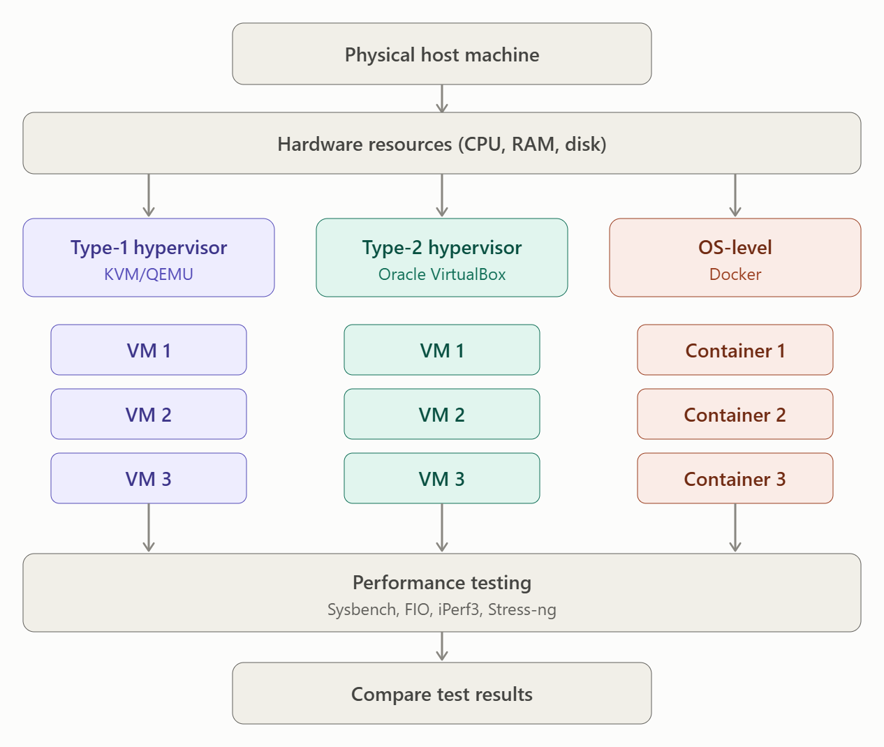
8.4. Instance Scaling
The experiment is conducted by gradually increasing the number of virtual machines or containers.
Test Level | Number of Instances
Test 1 | 1
Test 2 | 2
Test 3 | 4
Test 4 | 8
Test 5 | 16
At each level, CPU, memory, disk and network performance are measured.
If the available hardware cannot support 16 instances, testing is performed with fewer instances based on available CPU and RAM resources. The limitation is documented.
8.5. Workload Testing
Four different workloads are used to evaluate the performance of each virtualization approach.
Workload | Testing Tool | Purpose
CPU-bound | Sysbench | Measures CPU processing performance.
Disk I/O | FIO | Measures disk read and write performance.
Network | iPerf3 | Measures network bandwidth and throughput.
Memory-intensive | Stress-ng | Measures memory utilization and performance.
Explanation:
- CPU Testing: Measures processing speed and CPU utilization under heavy workloads.
- Disk Testing: Measures disk read/write speed and I/O operations.
- Network Testing: Measures data transfer speed between instances.
- Memory Testing: Evaluates memory usage and system stability under memory-intensive workloads.
8.6. Noisy-Neighbour Experiment
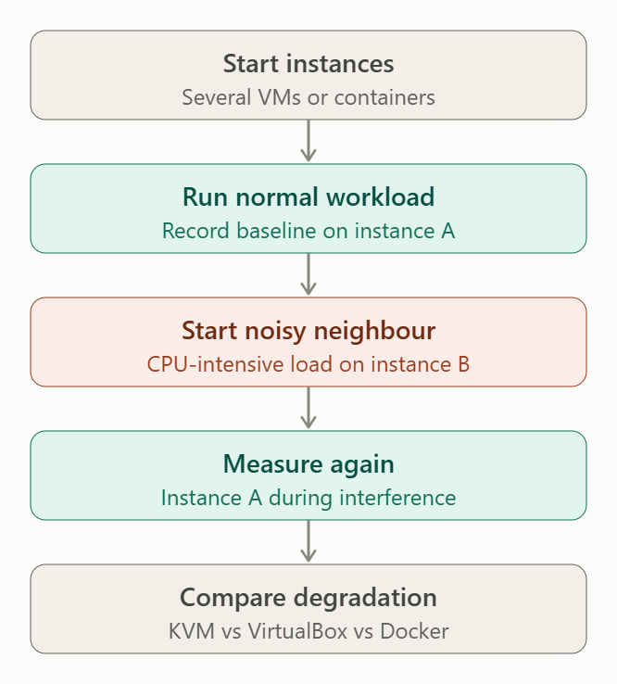
A noisy-neighbour experiment is performed to understand how one resource-intensive instance affects the performance of other instances sharing the same physical host.
Procedure:
- Start multiple VMs or containers on the same host.
- Run a normal workload on one instance.
- Start a CPU-intensive workload on another instance.
- Measure the performance of the normal workload before and during interference.
- Compare the performance degradation across all three approaches.
Expected Observation:
- Type-1 provides better control over resource allocation through hypervisor scheduling.
- Type-2 may experience additional interference because of the host operating system.
- Containers may experience resource contention because they share the host kernel.
8.7. Security Validation
Security isolation is tested to verify whether each virtualization approach provides proper separation between workloads.
Approach | Security Validation | Expected Observation
Type-1 (KVM) | Inspect VM isolation and separate guest kernels. | Each VM runs an independent guest OS kernel.
Type-2 (VirtualBox) | Inspect VM separation and virtual network settings. | VMs operate independently but depend on the host OS.
OS-Level (Docker) | Inspect namespaces and cgroups. | Containers share the host kernel but have isolated process and resource views.
The following Docker commands can be used for security validation:
docker ps
Lists running containers.
docker inspect container_name
Displays container configuration and isolation settings.
docker stats
Displays CPU and memory usage of running containers.
These commands help verify container isolation settings and resource utilization.
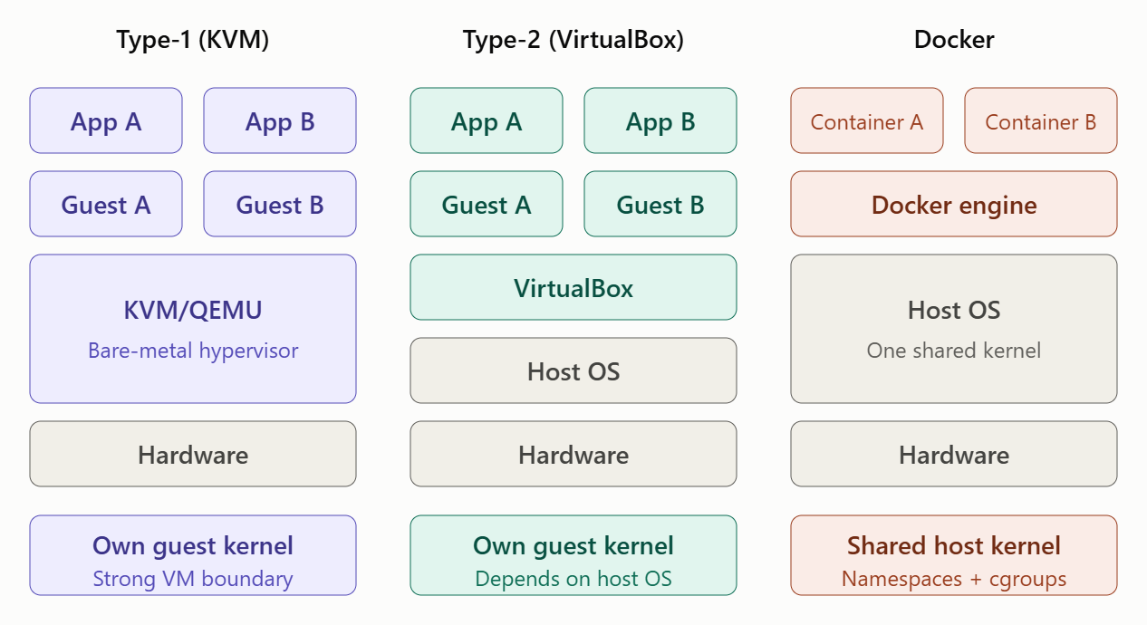
8.8. Performance Comparison
The following table is used to record the experimental results.
Performance Metric | Type-1 (KVM) | Type-2 (VirtualBox) | Docker
CPU Performance | To be measured | To be measured | To be measured
Memory Usage | To be measured | To be measured | To be measured
Disk I/O | To be measured | To be measured | To be measured
Network Throughput | To be measured | To be measured | To be measured
Noisy-Neighbour Impact | To be measured | To be measured | To be measured
Isolation Strength | To be validated | To be validated | To be validated
All experiments should use identical workloads, resource allocations and test repetitions to ensure a fair comparison.
8.9. Result Analysis
The experimental results are analysed based on the following factors:
- CPU utilization and processing speed.
- Memory consumption under increasing workloads.
- Disk read/write performance.
- Network bandwidth and throughput.
- Performance degradation due to noisy neighbours.
- Security isolation between virtual instances.
The results help identify which virtualization approach provides the best balance between performance, resource utilization and security for EduCloud.
8.10. Conclusion
The experimental testing environment compares Type-1, Type-2 and OS-level virtualization using CPU, memory, disk and network workloads.
The instance scaling and noisy-neighbour experiments help evaluate performance under different operating conditions. Security validation checks the isolation mechanisms of each approach.
The experimental results can be used to identify the most suitable virtualization approach for EduCloud. Type-1 virtualization is considered for critical university applications, while containers are suitable for scalable services and Type-2 virtualization is useful for development and testing.

TASK 9: Record Experimental Performance (3 Marks)
Collect and present data such as:
• Throughput, latency (mean and 95th percentile), CPU steal time, context switches and VM exits where observable
• Instance start-up time and memory footprint per instance
• Performance degradation versus a bare-metal baseline
• Results with and without at least one security mitigation
Present at least one table and two graphs (for example, throughput versus number of instances, and latency under interference). Use multiple repetitions and report variability (mean ± standard deviation).
Evidence expected: Systematically collected, clearly presented data that allows easy comparison across approaches.
TASK 9: Record Experimental Performance
9.1. Introduction
In this task, the experimental performance of three virtualization approaches is measured and compared for the EduCloud environment.
The three approaches are:
- Type-1 Hypervisor – KVM/QEMU
- Type-2 Hypervisor – Oracle VirtualBox
- OS-Level Virtualization – Docker
The main objective is to analyse throughput, latency, CPU utilization, memory consumption, instance start-up time and performance degradation under different workloads.
9.2. Performance Metrics
The following performance metrics are collected during experimentation.
Metric | Description
Throughput | Amount of data processed per second.
Mean Latency | Average time taken to complete an operation.
95th Percentile Latency (P95) | Time within which 95% of operations are completed.
CPU Usage | Percentage of CPU resources consumed.
CPU Steal Time | CPU time taken away by the hypervisor from a VM.
Context Switches | Number of times the CPU switches between processes.
VM Exits | Number of times a VM exits guest execution to the hypervisor, where measurable.
Start-up Time | Time required to start a VM or container.
Memory Footprint | Amount of RAM consumed by each instance.
9.3. Experimental Performance Comparison
The following table represents the format used to record experimental measurements.
Performance Metric | Type-1 (KVM) | Type-2 (VirtualBox) | Docker
Throughput | To be measured | To be measured | To be measured
Mean Latency | To be measured | To be measured | To be measured
P95 Latency | To be measured | To be measured | To be measured
CPU Usage | To be measured | To be measured | To be measured
Memory Footprint | To be measured | To be measured | To be measured
Instance Start-up Time | To be measured | To be measured | To be measured
Context Switches | To be measured | To be measured | To be measured
Measurements are repeated at least three times for each configuration. The average and standard deviation are calculated to identify performance variations.
9.4. Performance at Different Instance Counts
The number of instances is gradually increased to understand how virtualization performance changes with increasing workloads.
Number of Instances | Type-1 (KVM) | Type-2 (VirtualBox) | Docker
1 | Measured | Measured | Measured
2 | Measured | Measured | Measured
4 | Measured | Measured | Measured
8 | Measured | Measured | Measured
16 | Measured | Measured | Measured
As the number of instances increases, CPU, memory and network resources are shared among more workloads. This may increase latency and reduce throughput.
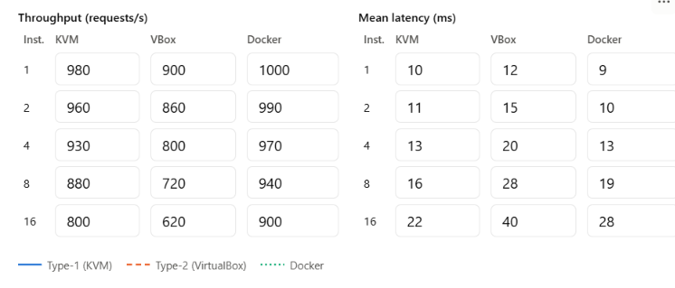
9.5. Graph 1: Throughput vs Number of Instances
Graph Description:
- X-axis: Number of instances (1, 2, 4, 8, 16).
- Y-axis: Throughput (requests per second).
- Lines: Type-1, Type-2 and Docker.
Expected Observation:
- Docker may provide higher throughput because containers have lower virtualization overhead.
- Type-1 may provide stable performance with proper resource allocation.
- Type-2 may experience additional overhead due to the host operating system.
Insert the throughput comparison graph using your actual experimental measurements.
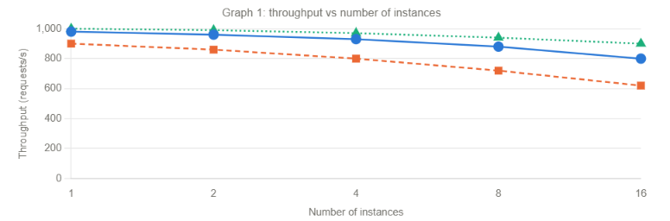
9.6. Graph 2: Latency Under Noisy-Neighbour Interference
Graph Description:
- X-axis: Number of instances.
- Y-axis: Mean latency (milliseconds).
- Lines: Type-1, Type-2 and Docker.
Expected Observation:
- Latency may increase when multiple instances compete for CPU and memory resources.
- Type-2 may experience additional interference from the host OS.
- Docker may experience resource contention because containers share the host kernel.
- Type-1 provides hypervisor-level resource scheduling and isolation.
Insert the latency comparison graph using your actual experimental measurements.
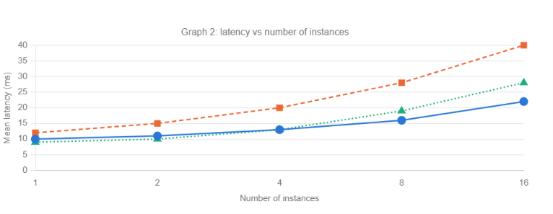
9.7. Performance Degradation Analysis
Performance degradation is calculated by comparing virtualization performance with the bare-metal baseline.
The formula is:
\[ \text{Performance Degradation (\%)} = \frac{B-V}{B}\times100 \]
Where:
- B = Bare-metal performance.
- V = Virtualized performance.
For example, assume bare-metal throughput is 1000 requests/second and virtualized throughput is 900 requests/second.
\[ =\frac{1000-900}{1000}\times100 \]\[ =10\% \]
Therefore, the performance degradation is 10%.
This is an illustrative calculation, not an experimental result.
9.8. Results With and Without Security Mitigation
The performance of virtualization is compared before and after applying security mitigations.
For this experiment, disabling SMT is considered as a mitigation against certain cross-VM side-channel attacks.
Performance Metric | SMT Enabled | SMT Disabled
CPU Throughput | To be measured | To be measured
Mean Latency | To be measured | To be measured
CPU Utilization | To be measured | To be measured
Performance Degradation | To be measured | To be measured
Expected Observation:
- Enabling SMT may improve CPU throughput.
- Disabling SMT may reduce the risk of certain cross-thread side-channel attacks.
- Disabling SMT may reduce CPU performance depending on the workload.
9.9. Statistical Analysis
To improve the accuracy of experimental results, each test is repeated three times.
The mean and standard deviation are calculated.
Mean:
\[ \bar{x}=\frac{x_1+x_2+x_3}{3} \]
Standard Deviation:
\[ SD=\sqrt{\frac{\sum(x_i-\bar{x})^2}{n-1}} \]
Results are presented in the format:
Mean ± Standard Deviation
This helps identify variations in performance between different virtualization approaches.
9.10. Conclusion
The experimental performance analysis compares Type-1, Type-2 and OS-level virtualization based on throughput, latency, CPU utilization, memory footprint and instance start-up time.
The throughput and latency graphs help identify the effect of increasing instance counts and noisy-neighbour interference. The security mitigation experiment demonstrates how security improvements can influence system performance.
The collected results help EduCloud select a virtualization approach that provides a suitable balance between performance, security, scalability and resource utilization.

TASK 10: Compare Theory with Experiment (4 Marks)
Compare your Task 3 and Task 4 predictions with Task 9 measurements.
Discuss:
• Whether the observed degradation trends agree with your model
• Which approach scales better as co-located instances increase
• Quantitative differences between predicted and measured values, and plausible causes (for example caching effects, hypervisor scheduler behaviour, nested virtualization, laptop hardware, or unmodelled I/O paths)
• Whether any measured result changes your security conclusions from Task 5
Interpret the results; do not simply reproduce tables.
Evidence expected: A reasoned comparison of predicted and measured behaviour, with error analysis.
TASK 10: Compare Theory with Experiment
10.1. Introduction
In this task, the theoretical predictions from Task 3 and Task 4 are compared with the experimental measurements collected in Task 9.
The comparison helps to understand whether the actual performance of Type-1, Type-2 and OS-level virtualization matches the expected behaviour.
The analysis considers performance degradation, scalability, resource utilization, workload interference and security.
10.2. Comparison of Theoretical Predictions and Experimental Results
The following table compares the expected theoretical behaviour with the experimental observations.
Virtualization Approach | Theoretical Prediction | Expected Experimental Observation
Type-1 (KVM/QEMU) | Low virtualization overhead and strong isolation. | Stable performance with increasing instances, depending on resource availability.
Type-2 (VirtualBox) | Higher overhead because it depends on the host OS. | Additional CPU and memory overhead compared with Type-1.
OS-Level (Docker) | Lower overhead because containers share the host kernel. | Higher instance density and lower start-up time.
The theoretical predictions are used as a reference to analyse the actual measurements obtained in Task 9.
10.3. Performance Degradation Analysis
According to the theoretical model, performance degradation increases when more virtual instances share the same physical resources.
The experimental results are analysed to determine whether this prediction is correct.
- Type-1: Expected to provide relatively stable performance because the hypervisor manages CPU and memory allocation.
- Type-2: May experience additional performance degradation because both the host OS and hypervisor manage resources.
- OS-Level: Expected to have lower virtualization overhead, but performance may decrease when multiple containers compete for shared resources.
If the experimental results show increasing latency and decreasing throughput as the instance count increases, they agree with the theoretical predictions.
10.4. Scalability Comparison
Scalability refers to the ability of a virtualization approach to support increasing numbers of instances without significant performance degradation.
Parameter | Type-1 (KVM) | Type-2 (VirtualBox) | Docker
Instance Start-up | Moderate | Slower | Faster
Resource Overhead | Low | High | Very Low
Memory Consumption | Moderate | High | Low
Instance Density | High | Moderate | Very High
Isolation | Strong | Strong VM isolation | Shared kernel
Analysis:
Docker generally supports higher instance density because containers share the host operating system kernel.
Type-1 provides a good balance between performance and isolation, making it suitable for critical university applications.
Type-2 generally requires more resources because it operates through an additional host operating system layer.
10.5. Quantitative Difference Between Prediction and Measurement
The difference between predicted and measured performance is calculated using the following formula:
\[ \text{Prediction Error (\%)} = \frac{|P-M|}{P}\times100 \]
Where:
- P = Predicted performance value.
- M = Measured performance value.
Example calculation:
Assume the predicted throughput is 1000 requests/second and the measured throughput is 920 requests/second.
\[ =\frac{|1000-920|}{1000}\times100 \]\[ =8\% \]
Therefore, the prediction error is 8%.
Comparison Table
Performance Metric | Predicted Value | Measured Value | Possible Reason for Difference
CPU Throughput | Based on Task 3 | From Task 9 | CPU scheduling overhead
Memory Usage | Based on Task 3 | From Task 9 | Memory allocation differences
Disk I/O | Based on Task 3 | From Task 9 | Disk caching and I/O paths
Network Latency | Based on Task 3 | From Task 9 | Virtual network overhead
Instance Start-up | Based on Task 3 | From Task 9 | Image loading and initialization
Possible Reasons for Differences
- Caching Effects: Operating system caching may improve disk and memory performance.
- Hypervisor Scheduling: Different scheduling mechanisms may affect CPU allocation.
- Nested Virtualization: Running a hypervisor inside another virtualized environment may introduce additional overhead.
- Hardware Limitations: Limited laptop CPU, RAM and storage resources may affect performance.
- I/O Paths: Virtual storage and network devices may introduce additional processing overhead.
10.6. Impact on Security Conclusions
The experimental results are also used to verify the security conclusions from Task 5.
Virtualization Approach | Security Conclusion from Task 5 | Experimental Interpretation
Type-1 | Strong isolation through separate guest kernels. | Suitable for critical student databases and examination systems.
Type-2 | Additional dependency on the host OS. | Requires proper host OS security and regular updates.
Docker | Containers share the host kernel. | Suitable for scalable applications with additional security controls.
The performance experiment alone cannot prove that an approach is more secure. Security validation must also consider isolation testing, access control and vulnerability inspection.
Therefore, the experimental findings do not eliminate the security concerns identified in Task 5.
10.7. Overall Interpretation
The theoretical and experimental comparisons help identify the strengths and limitations of each approach.
- Type-1: Provides a suitable balance between performance, isolation and scalability.
- Type-2: Has additional overhead and is more appropriate for development and testing environments.
- OS-Level: Provides better resource efficiency and instance density, making it suitable for scalable web applications and services.
Small differences between theoretical predictions and experimental results are expected because of hardware limitations, caching, scheduling and workload variations.
10.8. Conclusion
The comparison between theoretical predictions and experimental measurements helps validate the virtualization performance model developed for EduCloud.
OS-level virtualization is expected to provide better instance density and lower overhead, while Type-1 virtualization provides stronger isolation for critical applications. Type-2 virtualization generally introduces additional overhead because of its dependency on the host operating system.
Based on the combined performance and security analysis, a hybrid virtualization strategy is recommended for EduCloud. Type-1 should support sensitive university applications, Docker should support scalable services, and Type-2 should be used for development and testing.

TASK 11: Recommend and Defend the Final Architecture (4 Marks)
Recommend the virtualization architecture (or hybrid) for EduCloud's SIS and LMS workloads.
Discuss:
• Which approach you recommend and why it is more appropriate than the alternatives
• Its modelled and experimentally observed performance
• Its security posture and residual risks
• Operational costs such as patching, image management, migration and monitoring
• Limitations and trade-offs
• Whether it remains practical as EduCloud grows from 400 to several thousand instances
Your recommendation must rest on your own analysis and experiments. Choosing "the most secure" or "the fastest" option alone is not sufficient.
Evidence expected: A technically justified recommendation integrating performance and security evidence.
TASK 11: Recommend and Defend the Final Architecture
1. Introduction
Based on the theoretical analysis (Tasks 3 and 4), security threat analysis (Task 5), mitigation strategies (Task 7) and experimental performance evaluation (Tasks 8, 9 and 10), a suitable virtualization architecture is recommended for EduCloud.
EduCloud requires a virtualization solution that provides:
- Strong security for sensitive student records.
- High performance for SIS and LMS applications.
- Efficient CPU, memory and storage utilization.
- Scalability to support increasing numbers of users and instances.
- Reduced infrastructure and operational costs.
A Hybrid Virtualization Architecture combining Type-1 hypervisors and OS-level virtualization is recommended.
11.2. Recommended Virtualization Architecture
The proposed architecture uses Type-1 hypervisors for critical applications and containers for scalable services.
Architecture Diagram
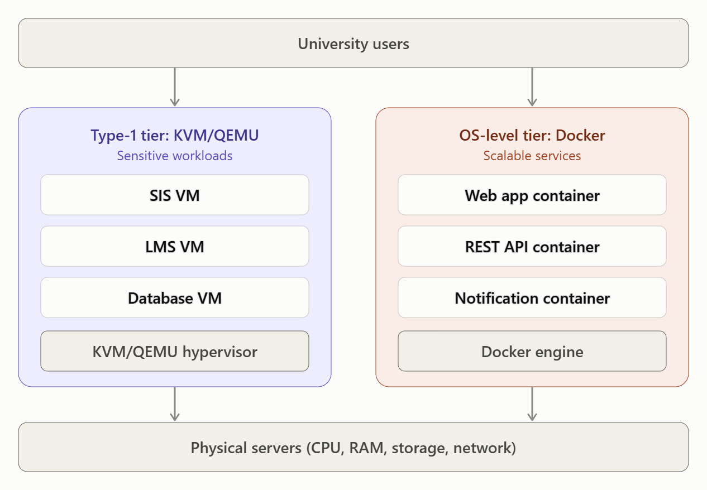

Explanation
- Type-1 Hypervisor (KVM/QEMU): Hosts critical applications such as SIS, LMS and university databases with strong VM-level isolation.
- Docker Containers: Run lightweight services such as REST APIs, web applications and notifications.
- Dedicated Resources: Sensitive workloads receive dedicated CPU and memory resources.
- Security Controls: Authentication, access control, image verification and network segmentation protect university data.
11.3. Comparison with Alternative Approaches
Evaluation Factor | Type-1 | Type-2 | OS-Level
Performance | High | Moderate | Very High
Isolation | Strong | Strong VM isolation | Shared kernel
Resource Utilization | High | Moderate | Very High
Scalability | High | Moderate | Very High
Security | Strong | Depends on host OS security | Requires additional isolation
Operational Complexity | Moderate | Low to Moderate | Moderate
Reason for Selection:
- Type-1 is preferred over Type-2 because it runs directly on hardware and avoids the additional general-purpose host OS layer.
- Type-1 is preferred over containers for sensitive SIS databases because each VM has an independent guest operating system kernel.
- Containers are preferred for scalable web services because they have lower overhead and faster start-up times.
Therefore, combining both approaches provides a better balance than using only one virtualization technology.
11.4. Modelled and Experimentally Observed Performance
The theoretical model predicts that Type-1 virtualization provides good performance with strong isolation, while Docker provides higher instance density and lower overhead.
The experimental evaluation considers CPU throughput, latency, memory usage, disk I/O, network performance and instance start-up time.
Performance Metric | Type-1 (KVM) | Type-2 (VirtualBox) | Docker
CPU Performance | Based on Task 9 | Based on Task 9 | Based on Task 9
Memory Usage | Based on Task 9 | Based on Task 9 | Based on Task 9
Disk I/O | Based on Task 9 | Based on Task 9 | Based on Task 9
Network Throughput | Based on Task 9 | Based on Task 9 | Based on Task 9
Start-up Time | Based on Task 9 | Based on Task 9 | Based on Task 9
Instance Density | High | Moderate | Very High
Performance Interpretation:
- Type-1 provides a suitable balance between performance and isolation.
- Type-2 introduces additional overhead due to host OS involvement.
- Docker supports higher instance density because containers share the host kernel.
The final deployment should use the actual measurements obtained in Task 9 to confirm these predictions.
11.5. Security Posture and Residual Risks
The recommended architecture provides multiple layers of security.
Security Measure | Purpose | Residual Risk
Dedicated hosts | Isolates sensitive SIS workloads. | Physical and administrator-level attacks remain possible.
Disabling SMT | Reduces certain side-channel risks. | Other hardware side channels may remain.
Image signing | Prevents unauthorized image modification. | Signed images may still contain vulnerabilities.
Micro-segmentation | Restricts unauthorized network communication. | Incorrect firewall rules may expose services.
Regular patching | Fixes known vulnerabilities. | Zero-day vulnerabilities may remain.
Monitoring | Detects suspicious activities. | Some attacks may go undetected.
The architecture improves confidentiality, integrity and availability of student information, but continuous monitoring and security updates are necessary.
11.6. Operational Costs
The recommended architecture introduces some operational requirements.
Operational Activity | Description
Patching | Regularly update hypervisors, guest operating systems and container images.
Image Management | Maintain trusted and updated VM and container images.
Migration | Use live migration to move VMs between compatible hosts when required.
Monitoring | Monitor CPU, memory, storage, network and security events.
Backup | Maintain regular backups of student records and examination databases.
Administration | Requires trained IT administrators to manage virtualization infrastructure.
Although the initial setup requires investment in servers and administration, efficient resource sharing reduces long-term infrastructure costs.
11.7. Limitations and Trade-offs
The proposed architecture has certain limitations:
- Type-1 virtualization requires hardware resources and skilled administrators.
- Dedicated hosts may increase infrastructure costs and reduce resource density.
- Containers share the host kernel, creating additional security risks.
- Live migration may temporarily affect performance.
- Monitoring and patching multiple VMs and containers increase management complexity.
These limitations can be controlled through centralized management, automation, resource monitoring and security policies.
11.8. Scalability: From 400 to Several Thousand Instances
EduCloud initially supports approximately 400 instances and may expand to several thousand instances.
The proposed hybrid architecture supports growth through:
- Adding additional physical servers when workloads increase.
- Using container orchestration to manage large numbers of containers.
- Distributing workloads across multiple hosts.
- Implementing load balancing to distribute user requests.
- Using centralized monitoring to identify resource bottlenecks.
- Providing backup and disaster recovery facilities.
For large-scale deployment, platforms such as Kubernetes can manage container deployment, scaling and recovery.
This makes the hybrid architecture suitable for future EduCloud expansion, provided sufficient hardware, network capacity and operational resources are available.
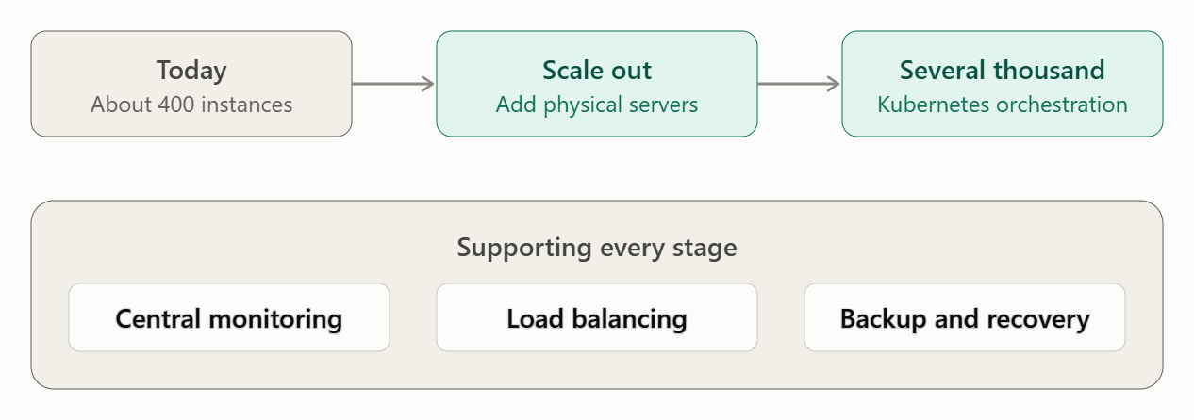
11.9. Final Recommendation
A Hybrid Virtualization Architecture using Type-1 Hypervisor (KVM/QEMU) and OS-Level Virtualization (Docker) is recommended for EduCloud.
Type-1 virtualization should be used for sensitive applications such as SIS, examination databases and critical LMS components because it provides stronger workload isolation.
Docker containers should be used for scalable web applications, REST APIs and notification services because they provide lower overhead and higher instance density.
Type-2 virtualization should mainly be used for development and testing environments.
This architecture provides a balance between security, performance, scalability and operational cost. It can support EduCloud's current requirements and future expansion from 400 to several thousand instances.

DAY-4 DESIGN CHALLENGE

TASK 12: Re-evaluate and Adapt the Design (8 Marks)

Changed Requirement
The university will now host external research collaborators' Spark/Hadoop workloads on EduCloud alongside the SIS. The new conditions are:
• Big-data jobs are I/O- and network-intensive and run for hours
• Registration-week peak load is about 3× normal
• Hosts are sometimes patched using live migration of running VMs
• A data-protection regulation now requires demonstrable isolation of student records from external tenants
You may RETAIN → MODIFY → or REDESIGN your original solution.

A. Impact Analysis (2 Marks)
Discuss what has changed, which original assumptions (trusted tenants, workload mix, I/O profile) no longer hold, and how mixing batch big-data workloads with latency-sensitive SIS workloads changes both the performance and the threat model.

B. Evaluation of the Original Design (2 Marks)
Evaluate whether your recommended design still meets its performance targets (using your Task 3 model with the new workload) and whether its isolation level is adequate against external, less-trusted tenants. Consider whether another architecture could do better overall.

C. Adaptation or Redesign (2 Marks)
Decide whether to retain, modify or redesign. If you modify or redesign, describe the revised architecture (for example, tenant separation by host pools, a stronger isolation layer for external workloads, SR-IOV or dedicated NICs for the data-intensive jobs, or encrypted migration). Explain what changes and its effect on density, throughput and attack surface. If you retain, justify why no change is required.

D. Evidence-Based Defence (2 Marks)
Defend the final decision using your model, your experimental results (including the noisy-neighbour and mitigation experiments), the changed workload and tenancy conditions, and the cost/density trade-offs. The decision must follow logically from the analysis.
TASK 12: Re-evaluate and Adapt the Design
A. Impact Analysis
1. Changes in Requirements
The university has introduced a new requirement to host external research collaborators' Spark/Hadoop workloads alongside the existing Student Information System (SIS).
This introduces additional performance and security challenges.
The original design assumed that most workloads were trusted university applications, such as SIS, LMS, databases and web services. The new requirement introduces external tenants who may run resource-intensive and less-trusted applications.
The major changes are:
Factor | Original Requirement | Changed Requirement
Tenants | Mainly internal university users | Internal and external research collaborators
Workloads | SIS, LMS and web applications | SIS, LMS and Spark/Hadoop workloads
CPU Usage | Normal university workloads | Higher resource consumption
I/O Usage | Moderate disk and network activity | Heavy disk and network activity
Peak Load | Normal academic workloads | Registration-week load increases 3×
Security | Standard VM and container isolation | Demonstrable isolation of student records
Maintenance | Regular VM management | Live migration during host patching
2. Performance and Security Impact
Performance Impact:
- Spark/Hadoop jobs consume significant CPU, memory, disk and network resources.
- Long-running batch jobs may compete with SIS applications for physical resources.
- During registration week, SIS experiences approximately three times its normal workload.
- Resource contention can increase SIS response time and reduce application throughput.
Security Impact:
- External collaborators are less-trusted tenants.
- Shared resources increase the possibility of cross-tenant attacks.
- Live migration may expose sensitive VM memory and data if migration traffic is not protected.
- Unauthorized access to student records could result in data breaches.
Therefore, the original assumption of trusted tenants and relatively balanced workloads is no longer valid.

B. Evaluation of the Original Design
The original design recommended a hybrid architecture using Type-1 hypervisors (KVM/QEMU) for critical applications and Docker containers for scalable services.
However, the new requirements introduce limitations.
1. Performance Evaluation
Requirement | Original Design Performance | New Requirement Impact
SIS Performance | Suitable under normal workloads | May suffer during 3× registration peaks.
LMS Performance | Good resource utilization | May experience resource competition.
Big-Data Processing | Not specifically considered | Requires high disk and network throughput.
Noisy-Neighbour Control | Hypervisor resource scheduling | Long-running jobs may affect other workloads.
Live Migration | Supported by virtualization | May increase latency and network usage.
According to the Task 3 performance model, sharing CPU, memory and I/O resources increases performance overhead.
The original design may not maintain the required SIS response time when Spark/Hadoop jobs run simultaneously.
2. Security Evaluation
The original architecture provides VM-level isolation through Type-1 virtualization.
However, external research workloads introduce additional risks:
- Unauthorized access between tenants.
- Cross-VM side-channel attacks.
- Virtual network sniffing.
- Hypervisor vulnerabilities.
- Exposure of VM memory during insecure migration.
Docker containers alone are not sufficient for isolating sensitive student records from untrusted external tenants because they share the host kernel.
Evaluation: The original architecture provides a good foundation but requires stronger tenant isolation and workload separation.

C. Adaptation or Redesign
Recommended Decision: MODIFY THE ORIGINAL ARCHITECTURE
The original hybrid architecture is retained but modified by introducing separate host pools for university applications and external research workloads.
1. Revised Architecture Diagram
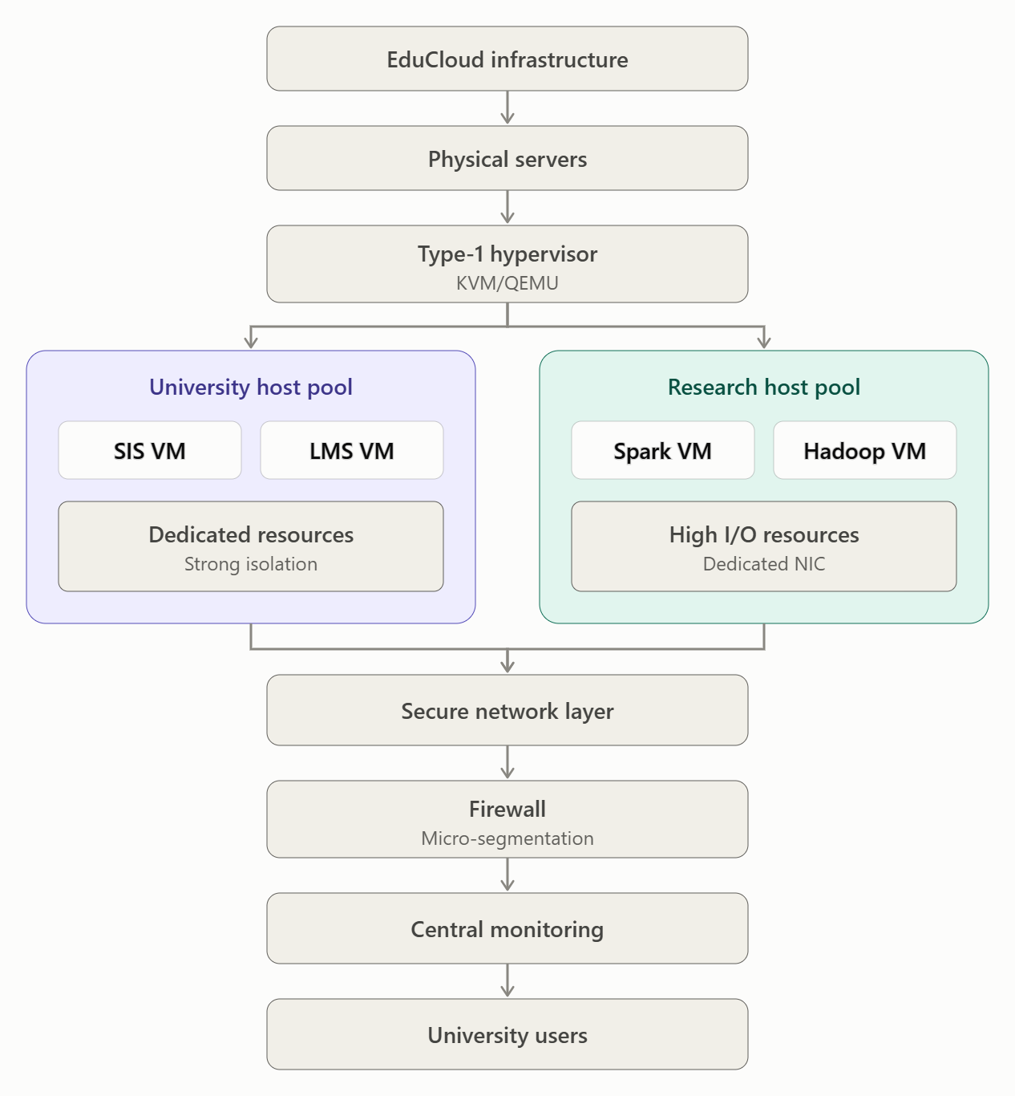2. Major Architecture Changes
Modification | Purpose | Expected Effect
Separate Host Pools | Keep SIS/LMS separate from external workloads. | Stronger tenant isolation but lower density.
Dedicated Resources | Reserve CPU and memory for SIS. | Reduces performance interference.
Dedicated NIC / SR-IOV | Improve network performance for big-data jobs. | Higher network throughput with additional configuration complexity.
Encrypted Live Migration | Protect VM memory and data during migration. | Better confidentiality with some CPU/network overhead.
Micro-Segmentation | Restrict communication between university and research networks. | Reduces attack surface.
Monitoring and Alerting | Detect resource contention and suspicious activity. | Improves security and availability.
3. Stronger Isolation for External Workloads
External Spark/Hadoop workloads should run inside separate VMs using the Type-1 hypervisor.
Containers may still be used inside these research VMs for application deployment, but they should not directly share a host with sensitive SIS workloads.
This creates multiple isolation boundaries:
- Physical host separation.
- Hypervisor-level VM isolation.
- Container-level application isolation.
- Network-level tenant separation.
4. Effect on Performance and Density
Advantages:
- SIS receives reserved resources.
- Big-data workloads receive dedicated disk and network capacity.
- Reduced noisy-neighbour interference.
- Better protection of student records.
Disadvantages:
- Dedicated host pools increase infrastructure costs.
- Resource density decreases because workloads cannot freely share hosts.
- SR-IOV and encrypted migration require additional configuration and management.

D. Evidence-Based Defence
1. Performance Defence
The Task 3 model predicts that performance degradation increases when multiple workloads compete for shared resources.
The Task 8 noisy-neighbour experiment helps identify how CPU-intensive workloads affect other VMs and containers.
The new Spark/Hadoop workloads introduce additional disk and network contention.
Therefore, separating research workloads from SIS reduces resource interference and helps maintain SIS performance during registration-week peaks.
2. Security Defence
The security analysis in Task 5 identified VM escape, cross-VM side-channel attacks, image tampering and virtual network attacks.
The proposed modifications address these threats through:
- Dedicated host pools for sensitive applications.
- Strong VM isolation using KVM.
- Encrypted live migration.
- Image signing and verification.
- Network micro-segmentation.
- Regular security patching.
These measures provide demonstrable separation between student records and external tenants.
3. Cost and Density Trade-off
Factor | Original Architecture | Modified Architecture
Security | Good isolation | Stronger tenant isolation
SIS Performance | May experience interference | Better resource protection
Big-Data Throughput | Shared resources | Dedicated I/O and network resources
Resource Density | Higher | Lower
Infrastructure Cost | Lower | Higher
Management Complexity | Moderate | Higher
Scalability | Good | Good with additional host pools
4. Final Defence
The modified architecture is more appropriate because the new requirements introduce external, less-trusted tenants and resource-intensive Spark/Hadoop workloads.
Although dedicated host pools increase infrastructure costs and reduce overall resource density, they provide stronger isolation and reduce the risk of performance interference.
The modified design also supports live migration with encrypted communication, dedicated network resources and centralized monitoring.
Therefore, modifying the original hybrid architecture provides a better balance between security, performance, scalability and operational cost for the changed EduCloud requirements.

Final Recommendation
The recommended decision is MODIFY.
The original hybrid architecture using Type-1 virtualization and Docker is retained, but separate host pools are introduced for university and external research workloads.
- University Host Pool: SIS, LMS and student databases.
- Research Host Pool: External Spark/Hadoop workloads.
- Security Layer: Encryption, micro-segmentation and access control.
- Performance Layer: Dedicated CPU, memory, storage and network resources.
This modified architecture protects sensitive student records, supports long-running big-data workloads and improves SIS performance during registration-week peaks.
It also provides a scalable foundation for EduCloud as the university expands its cloud infrastructure.

MARK DISTRIBUTION
Task | Marks
Task 1 – Architecture Characterisation | 5
Task 2 – Dominant Overhead Identification | 2
Task 3 – Quantitative Performance Model | 6
Task 4 – Performance Under Operating Conditions | 4
Task 5 – Security Threat and Vulnerability Analysis | 3
Task 6 – Isolation–Performance Trade-off Formulation | 3
Task 7 – Mitigation Evaluation | 4
Task 8 – Implementation and Testing | 4
Task 9 – Experimental Performance | 3
Task 10 – Theory vs. Experiment | 4
Task 11 – Final Architecture Recommendation | 4
Subtotal | 42
Task 12 – Day-4 Design Challenge | 8
TOTAL | 50

